Project Merlin

Due Diligence Report

20 June 2000

27 June 2000

The Board of Directors
Enron Europe Limited
40 Grosvenor Place
London SW1X 7EN

Dear Sirs

REPORT ON THE RESULTS OF DUE DILIGENCE PROCEDURES CONDUCTED ON MG PLC

We are pleased to enclose our report setting out the results of the procedures we conducted in association with your due diligence on MG plc, in connection with CSFB’s recommended cash offer on behalf of Enron Investments plc, for the entire issued share capital of MG plc in accordance with the terms of our engagement letter dated 14 June 2000, a copy of which is attached in Appendix I hereof.

The enclosed report has been prepared principally from information supplied by and obtained from discussions with the Directors, employees and agents of MG plc and its subsidiaries pursuant to the scope of the work agreed in the engagement letter. As agreed with you in our engagement letter, unless otherwise stated in our report, we have not sought to verify the information contained herein nor to perform the procedures necessary to enable us to express an audit opinion on any of the financial or non-financial information contained in this report. Indeed, as you will appreciate, much of the additional, non- financial information contained in this report cannot be subjected to audit or otherwise independently verified.

The Directors of MG plc have confirmed in writing to us: the opinions attributed to them and other employees in the report; and that (to the best of their knowledge and belief) they have made available to us all significant information relevant to our report of which they have knowledge.

This Report is dated 20 June 2000 and may only be relied upon in respect of the matters to which it refers. In relying upon this Report, you agree that we have no responsibility to and we will not perform any work subsequent to 20 June 2000 nor to consider, monitor, communicate or report the impact upon MG plc of any events, circumstances or inaccuracies which may in future occur or may come to light subsequent to 27 June 2000 (“Subsequent Events”). To the extent that any such Subsequent Events do or may affect your assessment of the proposed transaction, you agree that the responsibility for identifying and assessing any such subsequent events (together with the risk of failing to detect such Subsequent Events) rests entirely with yourselves.

This report is provided solely for your information in connection with your proposed acquisition of MG plc. Therefore you should not, without our prior written consent, refer to or use our name or the report for any other purpose, refer to them in any investment circular or other document, or make them available or communicate them to any other party. We accept no liability to any other party who is shown or gains access to this report.

Yours faithfully

Arthur Andersen
Contents
Page
1. Executive summary 6
1.1. Scope of report 6
1.2. Access to information 6
1.3. Review of 30 September 1999 Financial Statements 6
1.4. Review of KPMG audit workpapers (section 3) 7
1.5. Accounts receivable and credit control 7
1.6. Accounts payable 7
1.7. Inventory 8
1.8. Intercompany balances 8
1.9. US GAAP adjustments (section 4) 9
1.10. Contingencies (section 8) 9
1.11. Regulation 9
1.12. Control Environment 10
1.13. Credit Procedures 10
1.14. Market share 11
1.15. Acquisitions 11
1.16. Arthur Andersen involvement as advisers to MG 11
2. Description of business 12
2.1. Overview 12
2.2. Formation of the plc group 13
2.3. Metals traded 14
2.4. Background to the London Metals Exchange (LME) 15
2.5. Regulation 16
2.6. Key executives 16
2.7. AA role as internal auditors to MG plc 17
2.8. Risk Factors 17
2.9. Financing of group 18
3. Review of KPMG workpapers 19
3.1. KPMG’s audit approach 19
3.2. Consolidation workpapers 20
3.3. Audit Committee file 21
3.4. MG Limited company only workpapers 23
3.5. MG MCC Limited company only workpapers 30
3.6. MGMR (Germany) 37
3.7. MG MCC Corp 38
3.8. MGLI 39
3.9. HB Limited 39
3.10. HB Inc 40
3.11. MG plc 31 March 2000 results 40
4. UK/US GAAP accounting policy differences 41
5. MG Limited 54
5.1. Current Operations 54
5.2. Financial Reporting 54
5.3. Analysis of MGL forward book at 9 June 2000 55
5.4. Valuation procedures 60
5.5. 31 March 2000 balance sheet 60
5.6. Policies and risk management procedures 67
5.7. Henry Bath 68
6. MG MCC Limited 70
6.1. Current Operations 70
6.2. Analysis of MGMCC forward book 70
6.3. Valuation procedures 73
6.4. Policies and risk management 73
6.5. Balance sheet at 31 March 2000 74
7. MG MCC Corp. 80
7.1. Organisation and Business 80
7.2. Current Operations 80
7.3. Related Parties 81
7.4. Business Risks 82
7.5. Financial Analysis 83
7.6. Operations 87
7.7. Commitments and Contingencies 89
7.8. MG Trade Services (India) Pvt, Ltd. 89
7.9. MG London Inc. 90
7.10. Henry Bath, Inc. 91
8. Commitments and contingencies 93
8.1. Guarantees 93
8.2. Forward commitments 93
8.3. Long-term contracts 94
8.4. Litigation 94
8.5. Acquisition of Wolff 95

APPENDICIES
I Engagement letter
II group structure
III Henry bath warehouse list
IV 31 March 2000 balance sheet
V Stock analyses at 9 june 2000
VI credit limits
Vii Position limits

Executive summary

Scope of report

In accordance with our engagement letter dated 14 June 2000, as attached in Appendix I, we have performed the requested specific procedures as appended to our letter on the MG plc (“MG”) Group.
We have included in this report additional matters, which came to our attention as a result of carrying out the requested specific procedures. This additional information is provided for the purposes of assisting the integration process. It is not intended to extend the scope of our work or to limit the scope of your normal enquiries.
These enquiries have been made in association with CSFB’s Recommended Cash Offer, on behalf of Enron Investments plc, for the entire share capital of MG plc.
The scope of our work on the 31 March 2000 balance sheet, as attached in Appendix IV, was limited to MG Limited (“MGL”), MG MCC Limited (“MG MCC”) and MG MCC Corp, by agreement with Enron on the grounds of materiality.

Access to information
Our work has been carried out under significant time pressure and our enquiries have by necessity been limited to discussions with David Tregar, the financial controllers of the main businesses and with KPMG.

Review of 30 September 1999 Financial Statements
Our review of the 30 September financial statements highlighted the following:
- Certain intercompany transactions are not eliminated (see 1.8 below), which was deemed to require a true and fair override; and
- Inconsistencies between Enron and MG’s current practice (detailed in section 4 of this report); and
- Consolidation entries principally all relate to the reclassification of interest expense to cost of sales; and
- The company was not required to comply in full with the Combined Code which details corporate governance rules for public companies, and detailed three areas of non-compliance in their 30 September 1999 financial statements. This was principally due to the length of time for which the company had been subject to these rules (four days). The three areas of non-compliance at 30 September 1999 have been subsequently resolved.

Review of KPMG audit workpapers (section 3)

The audit appeared to have run smoothly with no major issues of disagreement brought to the audit committee or management’s attention. The main area of judgement was the slight adjustment to volatilities for a long dated aluminium option book. KPMG were comfortable with the valuation adopted.
For a detailed review of their workpapers for the 30 September 1999 audit, see section 3.

Accounts receivable and credit control
For a detailed analysis of work performed see sections 5.5, 6.5 and 7.5.
We performed the procedures specified in our engagement letter, with the exception of subsequent cash testing – results are documented in sections 5.5, 6.5 and 7.5. Due to the way in which these companies manage their debtors, primarily netting debtor and creditor positions by counter-party and reviewing credit limits based on the net balance, subsequent cash receipts testing was not deemed to be a useful test of debtor balances.
We did not identify any further bad debt issues, however we did note that several customers were over their credit limits. Further, it should be noted that MG Limited and MG MCC Limited do not formally review credit exposure by customer on a combined basis and therefore MG as a group may be exposed to credit risk not yet identified.

Accounts payable
For a detailed analysis of work performed see sections 5.5, 6.5 and 7.5.
We performed the procedures specified in our engagement letter, with the exception of subsequent cash disbursements testing – results are documented in sections 5.5, 6.5 and 7.5. Purchases of physical metal are occasionally paid for in advance. Warrants are generally bought through the London Clearing House (“LCH”). The LCH net debtor/creditor balance swings on a day to day basis depending upon transactions undertaken that day. Other expenses are low and principally consist of salaries and other overheads.
Repo finance was tested as part of the inventory work discussed above.
We did not identify any issues in accounts payable.

Inventory
Inventory is held in the form of physical stock and warrants. For verification procedures undertaken on inventory at 9 June 2000, see sections 5.5, 6.5 and 7.5. We verified over 50% of the group’s stock balance to third party paper records at this date and identified no exceptions. We also confirmed all repo stocks with third parties and identified no exceptions. We confirmed that the stock balance at 9 June 2000 reconciled to the balance included in the 31 May 2000 Balance sheet for MGL and MCC. We also confirmed that this balance sheet was prepared on a consistent basis with the 31 March 2000 balance sheet.
Currently, approximately 60% of all stock held by Henry Bath warehouses belong to MG plc companies. This percentage varies typically between 0% to 80% depending upon the company’s strategy and market conditions at any time. Conversely, of MG plc’s current total stock value of $1.5 billion, approximately 20% of this is held in Henry Bath warehouses.

Intercompany balances
During the course of our work we noted several types of intercompany transactions which are deliberately not eliminated on consolidation. The most significant are detailed below.
Henry Bath warehouse rent and exit fees are both recorded by Henry Bath in turnover (exit fees recognised when the stock enters the warehouse). Rent is recorded by MG companies in cost of sales, and exit fees are not recorded by MG companies until paid.
MG MCC may hedge a client position through MGL. MGL may then hedge its position with MCC through a third party, and record the spread on these positions in financial services income. However MCC will record the spread on its transactions in cost of sales. The offsetting gain or loss on the MGL/MCC transaction is not eliminated.

US GAAP adjustments (section 4)

Our report identifies the principal issues that need to be addressed in converting MG’s numbers to Enron’s US GAAP accounting policies.

Contingencies (section 8)

MGL has an indemnity from Metallgesellschaft AG (“MGAG” – the group’s former parent and current 40% shareholder in MG plc) against litigation from Codelco arising from alleged incentives paid by an MGAG group company (not MGL) to an employee of Codelco several years ago.
The group is also indemnified by MGAG against all tax issues.
A legal case associated with a former US director (Mason) has been recently settled for $700,000. The group expect this to be recovered from MGAG but it has yet to be paid. This has been recorded as a receivable by the group, but MGAG has not yet confirmed that it will repay this amount.
KPMG’s audit did not identify any issues to do with Sumitomo and nothing has come to our attention to suggest that MG plc or its subsidiaries are implicated in that affair. MG plc are indemnified by MG AG against any Sumitomo exposures.
The group has a securitised loan from a syndicate of banks of $250 million (currently fully drawn down). The security over this loan is in the form of cross-guarantees and, for MGL which cannot give cross guarantees for regulatory reasons; by a mortgage held by the syndicate group over MG Limited’s share capital.
Through our discussions with David Tregar we have not become aware of any other significant contingencies that are not detailed within this report.

Regulation

MGL is regulated by the SFA. MG London Inc. is a Clearing member of NYMEX and is registered with and regulated by the National Futures Association (‘NFA’) and Commodity Futures Trading Commission (‘CFTC’). There were no major matters that KPMG noted as outstanding between these entities and their regulator.
- Action should be taken to ensure good communication with the regulators during and after the integration process as regulators can obstruct normal business if their concerns are not met.
- Thought should be given to the level of regulatory support required for the long term.
Henry Bath’s warehousing activities are monitored by the LME. MGL is subject to LME monitoring in relation to its trading in LME contracts and MG MCC is subject at a more distant level to LME monitoring as an associate member.

Control Environment

KPMG’s audit relied extensively on controls testing. They considered the environment strongly controlled at both MGL and MG MCC in particular. Whilst we are not in a position to give an informed view, our enquiries suggest that MG MCC has a slightly less rigorous approach, probably as a result of not being regulated.

Certain accounting policies are not consistent throughout the group, though not considered material by KPMG. Information systems are not yet uniformly adopted. Credit management is not yet consolidated. These are all symptoms of the group having only recently come under a single management ahead of the flotation.

- In drawing up action plans for integrating the MG group, it should be remembered that systems and operations are running separately and one solution to fit all may not work.

Credit Procedures

The group does give credit, as is custom in the market. This means that additional resource may need to be allocated early on to move MG onto Enron’s systems quickly to avoid duplicate systems, but more importantly to ensure credit decisions are made both in line with Enron’s approach and in a transparent way to ensure MG’s customer service is not affected.
- You may wish to discuss the practicalities of this with David Tregar at an early stage.

Market share

MGL and MG MCC are significant players in their markets. This opens up significant opportunities in terms of market intelligence and developing market price opportunities through stock ownership. As with many advantageous positions there are also disadvantages.
- You should consider post acquisition strategies with a view to their effect on market perceptions.

Acquisitions
MG has a number of acquisitions underway. The most significant is the purchase of the customer base of Rudolf Wolff, a long established LME broker currently owned by Noranda Inc. The deal does not involve a corporate acquisition. About 50 employees may be taken on and some physical stock and debtors may also be acquired. The key risks are whether the customers will transfer or will fall away. MG has done due diligence and has an assessment prepared by Ernst & Young of customer overlap. On the basis of that analysis and past experience of similar deals, MG has agreed to pay $6 million for goodwill and $1 million for various facilities which Wolff will continue to provide for a period of one month.. The actual cash amounts to be paid will be substantially greater than the $7 million as payment is to be made for working capital amounts.
- You may wish to discuss with MG the Rudolf Wolff employee selection process as this may differ post acquisition of MG by Enron, however we understand that Enron has been involved in the due diligence process for this acquisition.
Arthur Andersen has been involved in performing some limited due diligence procedures on Wolff by MG plc.

Arthur Andersen involvement as advisers to MG
You are aware that Arthur Andersen are tax advisers to MG Limited. No tax matters are dealt with in this report and we understand you have made your own enquiries on tax matters.
Arthur Andersen were appointed internal auditors to the MG group at the end of 1999. The team have carried out one inspection to date (see section 2.7).

Description of business

Overview

The group is organised into two operating divisions – Merchanting and Financial Services. The group is also in the process of developing an on-line metal trading system and a fund management arm. For the 6 months ended 31 March 2000, brokerage, merchanting and warehousing contributed to gross profit (before interest) in the proportions 33%, 49% and 18% respectively. Financial Services – Brokerage and Trading
MG Limited (MGL) is one of the leading LME members and is a ‘ring dealer’. It engages in brokerage and market making in LME, COMEX and over-the-counter ("OTC") contracts.
The brokerage business generates commission executing client orders. The market making business generates trading income.
Over-the-counter trading offers off-exchange trading of contracts. These contracts can be tailored to meet the needs of the customer and have non-standard settlement dates. OTC trading offers higher margins than standard LME contracts.
The business trades metals futures and options as well as physical stocks for its own account.
One of the business’ main strategy is in contango metals financing. It enjoys competitive advantage in this area as it has access to its own warehouses.

Financial Services – Warehousing
The Henry Bath group is predominately a metals warehousing businesses storing metals, cocoa and general goods. At 31 March 2000 its warehouses contained approximately 18% of all LME metals stocks world-wide. These stocks were held in locations around Europe and also the United States and Singapore. The group has over 40 warehouses in Europe, the US and Asia. Over half the warehouses are used for the storage of LME metals, with the remainder being used for the storage of cocoa and general goods. For a full listing of Henry Bath warehouses, see Appendix III. It should be noted that Henry Bath both own and lease these warehouses.

Merchanting - Metals and Concentrates
MG MCC Ltd and MG MCC Corp act as merchants and traders in non-ferrous metals, principally copper, nickel and aluminium, and in copper concentrates. The merchanting companies also take market positions.

Merchanting – Recycling
The group, through its German subsidiary, MG Metals Recycling, acts as a principal merchant and trader in recycled non-ferrous metals.

Electricity
MGL has recently commenced electricity trading but this is still an embryonic activity.

Internet trading
The group has two Internet trading activities – ‘Market Maker’, which was developed in-house and is currently used by a significant portion of MG’s clients, and a joint venture ‘EMETRA’.
In October 1999 MG launched Market Maker as the first Internet based metals trading system and commenced online dealing in aluminium and copper in January 2000. Market Maker allows MGL clients to place LME orders, receive executions and exchange messages over the internet. The company has just announced that it intends to broaden access to its online metals-trading systems by allowing LME clearing members to use the system with immediate effect.
In February 2000 MG announced a joint venture with Internet Capital Group and Safeguard International Fund, to develop an Internet based market place for non-ferrous metals. MG has a 25% interest in the Joint Venture, with an option to purchase an additional 25% by December 2000. It is intended that the joint venture, called EMETRA, will establish a world-wide business-to-business (B2B) e-commerce trading platform for the non-ferrous metals markets, including physical trading and the trading of futures and options contracts.

Fund management
The group currently has one fund which has no third party investors. It is actively seeking new funds and is keen to attract third party investors in the future.

Formation of the plc group
The Metallgesellschaft AG (“MGAG”) group has been involved in metals merchanting since its origins in the early 19th Century. The core businesses within MG plc were established by MGAG as follows.
MGL was established as an LME broker in 1974 with a small minority interest held by Nisho Iwai. Since incorporation MGL has never made a loss.
Over the years, MGL has consolidated its strong market position with acquisitions of competing businesses – Henry Bath in 1986, Charles Davis in 1990 and Billiton Metals in 1998.
MG MCC limited was established in London in 1989. It went on to merchant metals in New York in 1990 and added copper concentrates trading the following year. All group merchanting activities were then moved to London or New York. In 1997 MCC acquired the trading portfolio of Cerro Sales Corporation. The tin portfolio of Henry Bath and aluminium portfolio of MCC in Germany were brought into MCC also that year. MCC Hong Kong and Metallgesellschaft China were also brought into MCC in 1997.
MG plc was incorporated in early 1999 and MGL, MG MCC Limited and MG (Holdings) Limited were transferred into plc. The new company was floated on the London Stock Exchange in September 1999.
A current group structure is attached in Appendix II.

Metals traded

Aluminium
The aluminium market is the largest non-ferrous metals market by volume and is dominated by large integrated primary aluminium producers. Supply originates from the Middle East, Australia, Europe, Russia and China and the main aluminium producers are Alcan Aluminium Limited, ALCOA Inc., Alusuisse-Lonza Group AG, Hydro Aluminium Limited, Pechiney S.A. and Reynolds Metals Company. Demand is driven by the transport, packaging, construction, machinery and electrical industries and the consumer goods markets and is concentrated in Asia, the US and Europe.

Copper
The copper market is second only to aluminium in terms of volumes of non-ferrous metals traded. The main refined copper producing countries are Chile, North America, China, the CIS and to an extent, Africa. Copper is primarily used for wire applications, copper alloys, copper tubing, plate sheet and strip. Demand is evenly spread across the US, Europe and Asia.

Nickel
Global production of nickel is increasing primarily due to an increase in Western demand for stainless steel. The main producing countries are the CIS, Canada and Australia. Over 65% of nickel produced is used in the production of stainless steel, for which demand is principally Western.

Copper concentrates
Copper concentrates are produced from sulphide copper ores. They typically contain a copper content of approximately 25-45 per cent, with the remainder being mostly iron and sulphur. However there is always the possibility that the copper concentrate may contain recoverable copper, gold or silver, the value of which may outstrip the total value of the copper concentrate. The probability of recoverable metals effects the price of copper concentrates.

Recycled metals
Recycled metals have become more important over recent years owing to environmental concerns and an increased focus on cost by consumers. Typically, demand for recycled metals has significantly exceeded supply. Products traded include recycled metals and residues consisting predominantly of copper, copper alloys and aluminium, as well as zinc, tin, nickel, nickel alloys, stainless steel and, to a lesser extent, rare metals.

Background to the London Metals Exchange (LME)
The LME is an international commodity, futures and options exchange. It specialises in the following non-ferrous metals - Copper, Primary Aluminium, Lead, Zinc, Nickel, Tin, Aluminium Alloy and Silver. It is not a cash cleared market.
Its floor and inter-office trading procedure is combined with a clearing system operating between principals based on bank guarantees and other forms of collateral. Both floor and inter-office trading are covered by a matching system run by the London Clearing House, whose role is to act as a central counterparty to trades executed between clearing members and thereby reduce risk and settlement costs.
There is an underlying assumption that physical delivery of the metal will take place on the prompt date, however this tends not to happen in practice as the majority of LME business is for hedge trading. Physical delivery is made possible through the LME’s network of warehouses.
LME approved warehouses are governed by a standard contract with the LME. Provided a warehouse keeps to the terms of the contract, the contract will run for an indefinite period. Either party may, however, terminate the contract on the service of six month’s prior notice.
The LME checks compliance with warehouse agreements through inspection visits from LME staff using a formalised audit programme. There is also an annual visit by external auditors (currently Arthur Andersen) who conduct a stock count and other appropriate checks. The LME also imposes a minimum capital requirement for their approved warehouses - the current requirement is £500,000.
LME contracts are delivered in the form of warrants, which entitle the holder to take possession of the metal described in the warrant at a specific LME approved warehouse. The warrant describes, inter alia, the weight, brand and location of the metal.
Recently the LME introduced an electronic storage system for recording stocks – SWORD, reducing the need for warrants themselves, which are bearer documents, to be transported between buyers and seller. These warrants, which are in a standard format, are electronically registered into the SWORD system. As LME contracts are bought and sold, the movement of the warrants from one SWORD account holder to another is recorded electronically. Details of ownership of warrants, of course, remain confidential but SWORD account holders are able to receive reports of their warrant holdings from the system. Warrants can be removed from a depository in order to take delivery of the metal.

Regulation
Various group companies are regulated by external organisations.
MG Limited is a Ring Dealing Member and a member of the London Clearing House. It is regulated by the London Metals Exchange and the SFA. Billiton Metal Limited is an Associate Broker Member of the LME. It is regulated by the LME and SFA.
MG MCC Ltd is an Associate Trade Member of the LME. Certain Henry Bath operated warehouses are LME bonded warehouses. Both are regulated by the LME.
The SFA imposes regulation over both capital requirements and conduct of business. The new consolidated regulation rules have not been applied to MGL as yet and it is uncertain whether they will apply to MGL. MGL has written to the SFA requesting it to confirm they will not be subject to consolidated regulation. No response has yet been received.
MG London Inc is subject to regulation in the US as a broker trading on Nymex.

Key executives
Key personnel at the principal group companies are as follows:
Entity | Individual | Title
MG plc | Thomas A. McKeever | Chairman
 | Mike Hutchinson | Joint Managing Director
 | Mike Farmer | Joint managing Director
 | David Tregar | CFO and Director of Risk Management
MG Ltd | Mike Hutchinson | CEO
 | Tim Jones | Director - Trading
 | Kevin Rhodes | Finance Director
MG MCC Ltd | Mike Farmer | CEO
 | Thomas Boettcher | Director - Trading
 | Howard Carter | CFO
Henry Bath | Ed Dablin | CEO
MG MCC Corp | Thomas A. McKeever | Chairman
 | Philip Bacon | Executive VP
 | Joseph Robertson Jr | Executive VP
 | Marcelo Parra | CFO

Our discussions with management concentrated on discussions with David Tregar, Kevin Rhodes, and Marcello Parra. Howard Carter was on vacation during the week of our work. Our work was focussed on the accounting records and trading operations of each company, and we met with various finance, trading and credit personnel as a result as follows: Nigel Grace, Nigel Geary, Hamish Scutt, Alan Jamieson, Mike Parnell, John Barret, and John Gill.

AA role as internal auditors to MG plc
Arthur Andersen were appointed as MG plc’s internal auditors at the end of 1999. To date, only one internal audit review has been carried out. The objective and scope of this review, which was on MG Limited, was as follows:
“to identify and evaluate risks and mitigating controls present in key processes.
The scope of the work incorporated a review of the following trading procedures:
Deal capture control environment (including deal input)
Futures pricing process
Options pricing process
Mark to market and daily profit and loss process
Trading risk control environment.”

There were no significant issues identified in the draft report.

Risk Factors
The following risk factors were identified in the Listing Particulars:

External influences on markets
Risk in trading activities
Dependence on external funding
Regulatory compliance
Credit risk
Dependence on key personnel
Trading with less developed countries
Dependence on information systems

Financing of group
The group requires significant funding to finance its physical stock holdings and margin requirements. At 31 March 2000 the group had bank loans and overdrafts of $546.7 million and loans under repurchase agreements (‘repos’) of $898.4 million. The group also had trade creditors of $422.4 million. The majority of the bank loans and overdrafts were in the form of unsecured ‘cash lines’ or ‘credit lines’, which may be withdrawn at no notice. The group has one longer-term syndicated facility led by Barclays Capital – a secured facility for $250 million which is generally fully drawn down. $100 million of this facility expires in August 2000, and $150 million expires in August 2001, however there is a change in control covenant requiring full repayment prior to Enron’s acquisition of MG. We understand that this requirement has been waived on the agreement that the full $250m will be repaid in August 2000.
The security over this loan is in the form of cross-guarantees and, for MGL which cannot give cross guarantees for regulatory reasons, by a mortgage held by the syndicate group over MG Limited’s share capital.
Both MGL and MCC undertake repo-financing activities, selling on physical stock or warrants to a third party, with a forward back-to-back buy back agreement. The counterparty for such transactions is usually a bank, but may be another LME broker or finance house. Over half the repo agreements undertaken by MGL and MCC may involve buying back the warrant or stock involved through the London Clearing House (see section 5.5).
For every repo agreement there are two contracts– a sale and a buy-back contract with fixed date for buy-back. The sale passes title of the stock to the third party on cash payment (usually on delivery of metal, warrants or warehouse release forms). The buy-back is at a premium and is contracted by both parties at the time of sale, however this does not guarantee that the counter-party will have the same stock to sell back to the Company, but in practice they always buy back the same metal.
Both contracts are entered into the system back-to-back, i.e. recording the receipt of cash and reduction in stock offset against an increase in stock for the buy-back and increase in creditors (i.e. stock never leaves the Balance Sheet). The difference between the sale and purchase price is taken to interest and reclassified to cost of sales on consolidation.

Review of KPMG workpapers
The group’s first consolidated statutory accounts covered the period from 30 March 1999 to 30 September 1999 on which KPMG Audit plc issued an unqualified audit opinion.
The comparative periods in the 30 September 1999 accounts and in the 31 March 2000 financial information, presented in the recent offer document aggregated the results of subsidiaries to present them as if they had been operating as one unit throughout the period being reported upon. This was achieved by adding the results and balances for each entity together and adjusting for any inter-company items.
AA spent 2 ½ days at KPMG’s offices in Dorset Rise, London reviewing their audit workpapers for the year ended 30 September 1999. We were also given access to the audit memorandum KPMG prepared for MG plc’s audit committee after the 30 September 1999 audit and the 31 March 2000 review of interim financial statements.
All views expressed in this section are those of KPMG as set out in their workpapers.

KPMG’s audit approach
KPMG’s audit approach for the 30 September 1999 audit was principally controls focussed, partly relying on controls work performed during an audit at 31 March 1999. We did not have access to the documentation of controls work performed for the March 99 audit.
The group audit plan involved distributing audit instructions to the auditors of material affiliates, highlighting risk areas and the overall audit plan. Submissions from audit teams included a reporting pack and Salient Features Memorandum.
Key risk areas for the group were identified as:
- Completeness and accuracy of deal capture
- Valuation
- Credit exposure
- Corporate Governance
- Y2K
- Intercompany balances.

Consolidation workpapers
All UK companies in the group prepare their reporting packs under UK GAAP. The US companies and Germany prepare them under US GAAP. The main UK GAAP adjustments that were made to the subsidiaries reporting under US GAAP for consolidation purposes were as follows:

Warehouse exit fees
This relates to metals held under warrants in Henry Bath warehouses. Under US GAAP, revenue recognition rules require that exit fees be recorded upon the removal of the inventory from the warehouse. Under MGL’s UK accounting policies, exit fees are recorded once inventory is placed in a warehouse, as the fees are then fixed in monetary terms and are considered to be unavoidable, although the actual timing of future withdrawal is not known. Exit fees could be discounted to their present value if the withdrawal date could be estimated, but the group does not discount these and an adjustment was never booked, as it was deemed to be not material.

Repos and reverse repos
Repos are sale and repurchase agreements. Metal is sold to a financial institution such as a bank, with a contract in place to repurchase it. Hence the substance of the transaction is that there has not been a sale and a purchase but a financing. The metal sold should be brought back onto the balance sheet and marked to market. Interest should be accrued on amounts borrowed, represented by the difference between the forward purchase value and sales value, and credited to the accruals balance.
A reverse repo is a transaction, normally intercompany, where the company buys metal with an agreement to sell it back. In this case, the inventory should not be recognised on the balance sheet. The amount lent should be shown as a short-term debtor and interest accrued thereon.
Adjustments were made to ensure these were reflected correctly on a consolidated UK GAAP basis – for example, reverse repos were removed from the balance sheet where they had been included and interest expense reclassified to cost of sales.

Debt factoring (MG MR Gmbh)
UK GAAP requires the factored debtors to be brought back onto the balance sheet. Under US GAAP the factored debtors are taken off balance sheet.

Grossing up of forward positions
Various US entities had netted their counterparty positions into a single trade debtor or trade creditor. Under the group’s UK policy, where a netting agreement is in place, the counterparty’s position may be netted off, and the balance is shown as ‘trade debtors’ or ‘trade creditors’. Where no netting agreement is in place, the amounts should be grossed up under ‘trade debtors’ and ‘trade creditors’. Adjustments were made to ensure debtors and creditors were correctly recognised under the group’s UK policy.

Leases
MG Recycling is a lessee under various finance leases. A UK GAAP adjustment to correctly recognise the interest charge under UK GAAP was deemed to be immaterial, and was not booked.

Deferred tax
Deferred tax assets (after valuation allowances) in respect of operating loss carry-forwards of $5.8m in MG MCC Corp. and $4.8 m in MG London Inc. recognised under US GAAP were reversed out and recalculated under UK GAAP.

Audit Committee file
The following points were noted to bring to the attention of the Audit Committee

Stock levels
MG and MCC together held 45% of the LME stock. The issue raised was of whether any valuation provision should be booked. It was decided that a provision was not required, as management explained that there was no market risk as all stock is hedged.

Current Asset Investments
Two current asset investments for $1 million each in offshore funds were marked to market. However, this treatment is inappropriate, as the investments are not held for trading purposes. The difference was considered to be immaterial. This treatment has not been repeated.

Henry Bath Limited provision
An adjustment of $0.5 million was booked to provide for rates and floor repairs not accrued by the company.

Bad debt provision
The combined bad debt provision of MGL and BML (“Billiton Metal Limited”) was $16 million, an increase of $2 million over the provision at 31 March 1999. This only covered specific doubtful debts and KPMG suggested a general provision may be prudent. This was rejected by management as unnecessary, which KPMG accepted. The largest specific debts provided against were China Resources Natural Co. ($6.1m), Clee Overseas ($6.7m) and Venture Tech ($1.4m). For further discussion of these items see section 5.5.

MG Metals Recycling Gmbh credit risk
As most customers are large industrials, the risk of credit default is considered to be low. However the largest risk is on prepayments made on purchases from Russia. KPMG’s work papers did not indicate whether any provision was recorded but indicated that the size of the position was not significant.

Billiton
A provision was set up in October 1998 on the acquisition of Billiton for the lease costs of their old office at Fenchurch Street as the company was integrated into MG. The fair value of the lease provision on the Fenchurch Street Rental as at 30 September 1999 was $2.3m. This provision was booked as an audit adjustment (and offset against goodwill on acquisition of Billiton).

MG MCC Corp
KPMG proposed profit and loss audit adjustments of $2.2m (no more detail at this level – assumed to be US/UK GAAP adjustments and no indication of whether expense or credit. (David Tregar could not provide us with further detail of these adjustments).
Aluminium (Alusuisse contract)

A series of long dated aluminium options were bought from Allusuisse in March 1999 which extend beyond December 2003. The vega of the position is $2m at 30 September 1999. The vega is the amount by which the valuation of the position changes per a 1% move in volatility. To price the aluminium, MGL extrapolated quoted LME volatilities forward on a linear basis and reduced the extrapolated prices by 0.05% volatility for every month beyond 27 months.
In April 1999 MGL sold some of the position to Morgan Stanley at 0.3% volatility. KPMG were not concerned about this, as they considered that this would back up MGL’s volatilities. The extrapolation of the LME curve was deemed to be the most judgmental area in the accounts. For an up-to-date analysis of the valuation of this contract see section 5.3.

MG Limited company only workpapers
MGL is one of the largest ring brokers on the LME. MGL execute client trades and take out proprietary positions. Income is derived from commissions, either flat fee or on spread, and from proprietary trading positions. Both client and proprietary positions are on the same book.
MGL trades in a wide range of metals including aluminium, aluminium alloy, copper, nickel, lead, tin, and zinc. MGL’s main activity is in future contracts trading and metal options, both exchange traded and OTC.
MG Physical (“MGLB”) is an account within MGL’s books to separately identify physical metal purchases and sales. MGLB deals with relatively small volumes, which are stored in HB, a registered LME warehouse. MGLB buys and stores metal in times of contango and sells forward thereby realising the rent implicit in the contango. If the market goes into backwardation, then MGLB may lend into the backwardation realising extra profits.
3.4.1 Issues
Omission of the repo deal in 1998
The audit workpapers referred to a repo deal which had not been properly recorded when the company restated their 1998 financial statements as a result of changing their accounting policy over repo stocks. As a result $5.3m was shown as realised in cash when in reality MGL still had the price risk. KPMG did not consider this was a deliberate error, and the repo was correctly reported in the Listing Particulars and 30 September 1999 accounts
Admin expenses
MGL pays bonuses to senior management via an offshore trust. Payments are made to the trust which then ‘lends’ the employees and directors money at commercial rates. The company has deducted payments made into the trust on their CT return. This is currently an open item with the Inland Revenue.
The provision for bonuses at 30 September 1999 was $7.2 million. KPMG pointed out that MGL have tended not to provide accurately for management bonuses in the past.
Bank reconciliations
Bank reconciliations were performed but there was no evidence of management review. The foreign exchange rates of minor currencies were not updated regularly.
3.4.2 Regulatory and compliance
SFA audit
The SFA performed an audit of MGL during the year. No significant problems were noted. MGL was granted Approved Credit Management Process (ACMP) status for its credit management and obtained approval for its LME option model.

SFA board notice 519 - proposed
Under certain limited circumstances this could require member firms to include the positions of subsidiary companies in their capital requirement calculations. If this was applied to MGL, the worst case scenario (as estimated by Kevin Rhodes) is that an additional $30m of capital will be required to meet the extended capital requirement. At 30 September 1999 MGL would have found it difficult to meet $30m of additional capital.
However, KPMG did not consider this to represent a going concern problem as strong representations have been made against the proposal by the Futures and Options Association representing 182 member firms. If the rule was introduced, MGL always have the option of unwinding their positions to continue trading.

LME audit visit
LME recently conducted an audit visit. MGL have yet to respond formally to the points raised. The main points are that time stamping of deals is inaccurate and there was an error in position reporting. None of these issues are thought to represent a going concern problem.
The LME have expressed concern that OTC contract notes do not clearly distinguish these trades from LME trades. The wording on these contracts has been amended in consultation with the LME legal department.

Product liability and legal issues
MGL are currently being sued by Codelco alleging a bribe to a Codelco employee led to the making of abnormal profits on copper contracts. MGL is vigorously contesting the claim. It also has an indemnity from MGTS, its former parent company, against any potential losses as the original counterparty for the bribe was another MGAG company.
3.4.3 Areas of management judgement
The main area of management judgement is the 0.05% month volatility adjustment made on the long dated aluminium contract. KPMG adjusted the volatility by 0.05% which had a negative net impact of $1.2 million. KPMG suggested that a valuation provision should be made against the pricing of the contract but management felt it was not necessary so none was recorded. This valuation method is referred to in section 5.4.
3.4.4 Post balance sheet reviews
MTM of Allusuisse contract $148m (7.12.99) At 30.9.99 - $119m (see section 5.3 for current valuation).

3.4.5 MGL deal capture - controls
There are three types of metal deals: LME trades, OTC trades and physical trades. Trading is in futures, options and physical metals. The company also undertakes FX trades but only where their clients have confirmed in writing to them that these trades are to hedge their underlying stock positions, in order to avoid becoming an ISD company (and hence being subject to further regulations).

Key risks
The key risks identified by KPMG are that the deals done by traders are not recorded onto the system, that non LCH deals are recorded incorrectly on the system, and that the AS400 system does not agree with the LCH system. Key risks are also that cut-off is incorrect and that positions taken breach the predetermined limits.

Key controls
The controls in place include reconciliations between AS400 and LCH and to open position reports and valuation reports. Tolerance reports are produced. These are exception reports listing all deals settled outside 5% of the previous day’s closing LME prices. Position limit reports are checked to the limits.
KPMG’s audit procedures focused on controls testing, although substantive testing and analytical review was also performed to ensure that all deals were accurately recorded, trading profits were accurately stated and to ensure that the interest income and expense were not materially misstated.
Testing confirmed that controls in place appeared to be working to support the completeness, existence and accuracy of LME and OTC trades. The AS400 and LCH reconciliation was carried out on a timely basis. All reconciling items at 30 September 1999 were cleared on 1.10.00, with no significant impact on profit.
KPMG noted that the categorisation of interest in the accounts has not been accurately maintained throughout the year. At the year end Nigel Grace carried out a review of interest and subsequently interest per the pack was reclassified from that recorded in the trial balance. Interest was then not significantly misstated. The accuracy of interest was proved in total and adjustments to individual categories substantiated. For further analysis of treatment of interest see section 4.
3.4.6 Tax- Open issues
- Tax treatment of a bad debt write-off (per David Tregar at 20 June 2000, this is now resolved);
- Allowability of income from an offshore metals fund (per David Tregar at 20 June 2000 this is now resolved); and
- Deductibility of contributions made to the IOM trust and general tax allowability of the trust.
3.4.7 Credit
The main issues relate to trading without trading agreements and lack of resources in the credit department.
KPMG tested the credit system and concluded that it appeared accurate but there seemed to be a lack of review of the new Billiton files (after the acquisition by MGL of Billiton) due to a lack of resources. KPMG tested significant exposures. Neither MGL or Billiton appeared over-exposed.
KPMG reviewed the specific bad debt provision and thought it seemed reasonable.
Initial margins (IM)
The system calculates an IM and MGL call for clients who do not have credit lines or where risk is known, for example China. The company may not call the full margin. The FSA audit raised concerns over this, as by not calling the margin or even including the margin in customers credit levels, the company could be exposed to increased credit risk.
3.4.8 Stock

Key risks
The risks in relation to stock relate to its existence, valuation, accounting for finance deals, and completeness of the rent accrual.
Stock is MtM on a daily basis – this is disclosed as a true and fair override in the plc accounts.
Note: If a company holds large stocks, for example 40% of the total market stock, then the company enjoys a monopoly position and can affect market price. Therefore the LME price should not be used, however management argue that it is appropriate as all stock is hedged. As at 30 September 1999 MGL held in excess of 40% of Copper A and 30% of aluminium of LME stocks.
Financing repos
For most repos, stock is given for the third party as collateral for the deal. All rights and obligations are retained by MGL, but in the event of default by MGL, the counterparty is entitled to keep the stock. The interest expense plus the forward profit or loss is reflected in the profit and loss account. The interest element is classified as interest expense in company only profit and loss accounts, but reclassified to cost of sales on consolidation. The forward profit is recorded in cost of sales for MCC and financial income for MGL.
Counterparties tend to be Al Rajhi, AIG, Barclays, Cargill, Netaxis bank, Banque Nationale de Paris, and Fendrake.
Audit risk
The audit risk is that although this is a finance deal, is indistinguishable from normal trades on the MGL system and hence may be overlooked. However, a spreadsheet detailing all repos is maintained by Gulio de Chiara.
An additional complication is that some finance deals (mostly AIG and Cargill) have a sale leg that is an OTC trade, while the purchase leg is from the market to avoid risk to the counterparty of MGL. It is nearly impossible to retrospectively identify these, and KPMG relied on management representation. These repo deals are accounted for in the same way as standard repos. For further discussion of repo agreements see section 5.5.
MGL also do reverse repos, usually with other group companies such as Billiton, as these represent secured lending for SFA purposes and don’t require additional capital resources.
Rent accruals
All warrants attract rent which is payable to the warehouse that holds the metal. Rent is set by LME and a full year’s rent for the owner of the warrant is payable on the 31st March in arrears. However, credit is received from counterparties if the warrant is purchased during the year.
3.4.9 Controls assessment
KPMG did not identify any weaknesses on the AS400 system, which was tested three times in the year. The valuation of stock appeared reasonable. Finance deals were properly accounted for and the warehouse rent was properly accrued.
3.4.10 Cash
Cash movements generally arise from trading and the payment of salaries and expenses.
Two main accounts are used: a Barclays account to cover payroll and admin expenses, and an HSBC account used for deal settling.
KPMG performed walk through tests on the cash systems and noted two weaknesses:
- The bank reconciliations had no evidence of review; and
- Some foreign exchange rates were not updated.
However, these weaknesses were considered to be minor. The risk of material misstatement was therefore deemed by KPMG to be unlikely.
We reviewed the bank replies received by KPMG – the only mention of security was in the Commerzbank reply which stated that the bank has the first and principal mortgage over the shares in Metallgesellschaft Limited (MGL). Commerzbank is one party in the syndicated loan facility, and this security applies to the entire $250 million loan – not just Commerzbank’s portion.

3.4.11 Transfer of the Billiton trades
MGL purchased Billiton Metals Limited (BML) positions on 30.10.98. From that day BML became an execution only broker, performing customer trades and backing them out of MGL. No further positions were taken by BML.
On the date of the take-over, MGL absorbed all BML positions onto its ledger. To do this BML performed the opposite trade to all its clients trades with MGL at market value into an account called the MGS account on Cortex. The corresponding account on MGL’s books (AS400) is the BEM account.
From the date of take-over until 23 January 1999, BML booked trades with customers on the Cortex system. All trades performed were backed out with an equal and opposite trade with MGL which was booked into the MGS account on Cortex. On 23 January 1999, MGL incorporated BML’s proprietary and client positions onto AS400 and closed off the BML Cortex system. From 23 January 1999 all trades were then recorded onto AS400.

Controls over the changeover period
The system was tested by KPMG as part of the year-end audit in June 1998. The documentation and testing of the controls over the Billiton position transfer to ensure the completeness and accuracy of deal transfer was completed in the March audit. KPMG confirmed with Nigel Grace that there had been no changes to the system for accounting for pre-acquisition Billiton positions.

3.4.12 Physical commodity trading division – MGLB
MGLB is the physical commodity trading division of MGL. MGLB maintain separate ledgers from MGL and these are consolidated into MGL’s results.

Trade systems
MGLB operate a clear uncomplicated control system which enables all trades to be accurately tracked and allows all LME hedges to be checked against actual physical trades and vice versa. The system was reviewed by KPMG in March and August 1999. No weaknesses in the system were identified that would lead to a material weakness.

Stock existence and valuation
MGLB holds two main types of stock: physical stock and warranted stock.
KPMG assessed the system for recording and valuing stock and concluded that the systems operated by MGLB are adequate in recording all stock held by them and correctly classifying it. Stock also seems to have been correctly valued. The prices used by MGLB slightly differed from those in the FT, but were found to be consistent with those used in other areas of MG plc.

Credit
KPMG raised the issue of reliance on British Aluminium given its consignment invoicing. The contract allows for a delivery to be made to British Aluminium but they are only invoiced for the delivery as and when they use the metal. This procedure seems fairly common as market practice. However there is a potential credit risk if British Aluminium were to go into liquidation, as recovery may prove difficult. The company is also relying on the integrity of British Aluminium’s stock usage system.

MG MCC Limited company only workpapers
The critical processes and principal audit objectives identified by KPMG during the audit for the year ended 30 September 1999 were to verify completeness of the deal cycle, test valuation of inventory and debtors, verification of inventory and capture of liabilities.

3.5.1 Deal cycle
The audit approach by KPMG was to test the operation of the key controls during the year, in order to obtain comfort over the completeness, existence and accuracy of recording of deals during the year.

a. Completeness of deal cycle
MCC has four types of trades: physical trades via the London office and via the New York office, and exchange trades with the LME and with Comex. MCC cannot itself trade on these exchanges, but must do so via a broker. MGL and MGLI acts as MCC’s broker for the LME trades and Comex trades respectively.
The key risks identified by KPMG in relation to the deal capture process are as follows:
- The risk that unauthorised trades are made;
- The risk that the position and counterparty limits are exceeded on the trading desk; and
- The risk that deals are input inaccurately into AS400.
As part of the audit procedures, KPMG identified and tested the client’s key controls that they assessed would mitigate the aforementioned risks.

Physical trades
When a deal is made, the following controls are in place:
On the London physical trades, two directors actively trade and are responsible for monitoring limits. Deal confirmations are reviewed by traders and initialled before they are sent off to the counterparty. On a daily basis, AS400 is reconciled back by a supervisor to the metal position book, also known as the dealers’ blotter, before the daily profit and loss is calculated. The daily profit and loss based on AS400 data is scrutinised by traders and back office staff for accuracy.
On the New York physical trades, deals are made under the supervision of a MCC director based in New York. Michael Farmer reviews the New York position on a daily basis. The details input by MCC Corp are reconciled to their summary daily. MCC Corp are allocated contract numbers in sequential blocks for completeness purposes. As in London, AS400 is reconciled to the metal position book before the daily profit and loss is calculated.
KPMG stated that in nearly all cases controls over deal capture operated as intended. However, in most cases, confirmations sent to counterparties were not returned. The management do not chase these but instead take silence as being proof of acceptance.

Exchange traded books
On the LME exchange trades, the key risks identified are unauthorised trading transacted by MGL as MCC’s brokers, inaccurate input of deals onto the AS400 system and the use of other brokers by MCC who do not give up the trade to MGL.
To reduce the risks associated with deal capture, a mismatch report is produced to compare MCC’s ledgers to MGL’s ledgers. If MCC have dealt through another broker, then provided that it has been recorded on the LME trade sheet and input onto the AS400, it will appear on the mismatch report.
On the Comex book, the key risks identified are that unauthorised trades are made by MGLI and that trades may be made by MGLI that are not recorded on AS400.
Communication with MGLI is on a senior level with traders dealing directly with New York. Positions are monitored by senior traders to ensure that the trades performed achieve the required result.
KPMG’s conclusion was that controls over deal capture operated as intended, and should ensure that deals recorded on the AS400 have been completely and accurately captured.

Sales and purchase invoicing
KPMG tested a sample of invoices as part of their audit procedures and concluded that invoices appeared to be accurately generated and processed and were received and produced on a timely basis.

Trade amendments
KPMG updated the system and control overview during their half-year work. As part of the year end audit, they selected and tested a sample of amended deals. All controls were found to operate for the deals tested.

b. Valuation of stock and open position
This involves the valuation of six classes of transactions: exchange trades stock held (LME or Comex), exchange traded open metal positions, physical stock, physical open metal positions, provisional billings, open foreign exchange positions.
KPMG identified the following risks:

Audit risk - Stock and positions are valued using metal and forward rates that do not reflect the market
KPMG followed a substantive approach to test LME prices, forward prices by extrapolation and fx rates. MCC uses a modelled 5pm (London time) Comex price set in order that it can value all its metal positions at London close of business prices. KPMG tested this system and found it accurate and reasonable in its basis.

Audit risk - Premia and discounts applied to physical stock and forwards do not reflect market values
KPMG felt comfortable that they obtained corroborative evidence to ensure that premia and discounts reflected market prices. KPMG concluded that MCC were generally prudent in valuing their stock and positions in relation to the market.
No provision has been set up by MCC to recognise potential losses on the premium or discounts where MCC entered into forward unpriced contracts. KPMG reviewed the unpriced listing as at 30 September 1999, and concluded that the unpriced book did not contain material future losses and hence the treatment by MCC seemed appropriate.

Audit risk - The same rates are not used to value similar positions
KPMG observed that all positions had been valued using the same sources of data.

Audit risk - The valuation methodology does not give a true and fair picture
KPMG stated that the valuation methodology used by MCC was acceptable but noted the following issues in relation to provisional billings:
Provisional billing occurs when stock has been passed to a counterparty but the price of the metal has not yet been agreed. A provisional invoice is prepared based on that day’s LME/Comex price.
However the substance of this transaction is that a sale has not yet taken place, but the AS400 systems treats it as a sale and hence records a profit or a loss. But since no price has been agreed, it can be treated as ‘stock’ and marked-to-market as all other physical stock. An adjustment is raised to eliminate the profit or loss resulting from the ‘sale’. The metal is not brought back on to the balance sheet but is marked-to-market.
KPMG raised the following issues:
- The forward sales leg is treated as though it was ‘stock’ to derive the market price. MCC use the cash price rather than the forward price to value the stock as it is more prudent (normally has a lower value).
As transactions are short-term and generally take place within one month the impact is unlikely to be material.
- The model does not apply commodity differentials as are applied for all other open sales contracts.
Nigel Geary (MCC) commented that this is because they have been included by the time that the provisional billing is made and are no longer appropriate.
- Turnover and cost of sales are included in the results for the provisional billings although it is uncertain that the provisional billing constitutes a sale especially as the deal is marked-to-market.
The above treatment is consistent with the prior year.

c. Valuation of debtor balances

Background
MCC have experienced a lengthening in credit days taken by counterparties. This is due in part to the slowdown in the global economy and increased business in USA which tends towards longer credit terms than north European counterparties.
However approximately 40% of all trades are made on delivery versus payment (‘DVP’). This mitigated the level of risk.
MCC did not have a general bad debt provision as at 30 September 1999. This treatment is consistent with prior years.

Key risks
Credit risk arises with trades where metal has been delivered but no cash has been received (‘trade debtors’) and where there is an unrealised profit recorded on open positions (MtM).

High level controls
KPMG understood that the way MCC reduces its credit risk is by only offering credit to reputable Western and a small number of highly reputable Far East counterparties. Credit is only offered after reference to external credit agencies and is only extended with certain limits. MCC develop long term relationships with counterparties and deal with a relatively few counterparties. This makes credit risk easier to identify and control. A credit controller employed to monitor credit, together with directors who have a close involvement in the process, help mitigate the risk.

Overall review of the credit portfolio
KPMG evaluated MCC’s credit portfolio as low risk because the overall credit portfolio is focused towards Western corporations and exposures were generally kept within limits. Additionally, the staff at MCC appeared to have an excellent understanding of counterparties and risks.
MCC suffered only one bad debt during the year, a $111k balance with Anton Noll, a company that went into liquidation. As a result of the cancellation of contracts with Anton Noll, MCC had to write-off an additional $238k MtM valuation arising on these contracts.

3.5.2 Inventory

Background
MCC has three kinds of stock: physical stock, exchange traded stock under warrants, and sale and repurchase agreements (‘repos’). Repos are treated as stock at period end due to substance over form as per FRS5. Repos are in effect securitised loans.
The risk that stock will be incorrectly stated in the financial statements is reduced by having independent sources of information. MCC’s low staff turnover may lead to a competently performed quarterly stock reconciliation. The valuation of stock has been covered above. The adequate operation of controls over deal capture and input also gives confidence in the accuracy, existence and completeness of stock.

Repos
KPMG agreed the details of stock under repurchase agreements at period end to third party confirmation. The completeness of repos with banks is checked as banks are asked an open question on the standard bank letter to give details of all balances and transactions. However, KPMG noted that due to the nature of the repos and the fact that there are a large number of forward deals, it can be very difficult to get 100% confidence that all repos have been captured. When Nigel Geary and Will Sell were asked if the spreadsheet detailing all of the repos was complete, they indicated that to the best of their knowledge it was.

Warranted stock
These were tested by agreeing stock details to stock warrants. The only material difference noted by KPMG related to the timing difference in recording of the Comex transactions. This caused MCC to include stock in their closing balance for which they had yet to receive the warrants. This led to an overstatement of stock and intercompany creditors by $1,771k. KPMG noted that similar differences had been experienced on prior audits but also noted that the only affect was in the balance sheet.

Physical stock
KPMG noted no material differences in agreeing the stock details to supporting documentation such as bills of lading, warehouse release forms and warrants.

3.5.3 Provisions and accruals
Provisions cover litigation provisions and potential losses in the unpriced stock. Accruals cover items such as general overheads, agency charges, contract expenses, cutting charges, and rent accruals.

Key risks
The key risks in relation to provisions and accruals are the following:

a. Costs are over or under accrued
KPMG concluded that accruals for overheads appeared reasonable, and there were strong controls over deal capture and familiarity of traffic with cost drivers relating to agency and cutting charge expenses. The rent accrual increased from $491k in 1998 to $5,922k in 1999. This was due to the increase in the level of warranted stock. After performing various tests KPMG concluded the increase seemed reasonable.

b. Insufficient provision is made for potential future losses within the unpriced stock
As explained under valuation, KPMG concluded that the review of contracts as at 30 September 1999 showed large positive balances indicating future profits, and hence a provision for future losses was not required.

c. Provisions are released to ‘manufacture’ profits.
1999 has seen a number of provisions reduced or removed from MCC’s books. As part of their audit procedures, KPMG reviewed the provisions on an account by account basis. KPMG concluded that the accruals held in MCC’s books were prudent and that there was a reasonable basis for the charges made.

3.5.4 Other assets
MCC holds tangible fixed assets (computer and office equipment, and motor vehicles), fixed asset investments, treasury bills and other assets including VAT, staff loans, and accrued interest. Fixed asset investments are mainly a 100% subsidiary, MG Hong Kong Ltd acting as an agent on MCC’s behalf. This subsidiary is not consolidated as all income is intercompany, and on the grounds of immateriality.

Key risks
The risks identified by KPMG are that fixed assets on the trial balance have not been updated for disposals and additions, that MCC’s investment in MG Hong Kong is not stated at cost less permanent diminution in value and that MCC do not own the treasury bills that MCC Corp holds on its behalf.
KPMG performed audit procedures and concluded that all material additions and disposals had been accounted for, the investment had suffered no diminution in value and confirmation was received from MCC Corp about the existence of treasury bills.
3.5.5 MCC Intercompany balances

Intercompany balances arise as a result of the sale and purchases of LME/COMEX metal warrants and related income within the group, and between group companies who pay freight charges, commissions, etc, on behalf of MCC. Intercompany balances also arise on intercompany loans and accrued interest and on the treasury bills held by MGLI on behalf of MCC.
KPMG identified some specific problems in relation to intercompany balances which are detailed elsewhere within this section.

3.5.6 MCC tax issues noted
The Inland Revenue requested information about a loan from MG Handel ($30m creditor) with respect to whether the transaction was at arms length or not.
3.5.7 MCC Cash
There are eleven foreign currency trading accounts with Barclays. Most trades are settled in US $ in US $ accounts.
MCC has loan facilities with Barclays Bank, Commerzbank, BHF Bank, Banque Nationale de Paris, Credit Lyonnais, and Hypo Vereinsank.
Risks
The risks involved in relation to cash are omission of accounts, going concern (cash flow) issues, fraud and cut-off.
Testing did not expose any weaknesses.

3.5.8 Management bias
KPMG assessed the risk of management bias, and stated that early indications are that MG plc as a whole had recorded revenues and profits in line with market estimates and there was no indication of profit manipulation. Final bonuses had not been determined by the end of the field work but had been accrued for based on prior year levels which management have confirmed are at a realistic level.
Due to the high level control environment and segregation of duties, fraud risk evaluated by KPMG was considered to be low.

MGMR (Germany)

Issues from the Salient Features Memorandum
UK GAAP differences identified by KPMG
The reporting pack of MGMR was prepared on the UK GAAP basis except for a pension accrual calculated in accordance with statutory tax regulations. The difference was booked at group level by MGAG. Secondly, forward positions were not discounted. KPMG documented a discussion with the KPMG London office in which it was agreed that the impact of the discounting should be supplied to KPMG London. AA did not find the result on file.
UK GAAP adjustments by MGMR
The adjustments done by MGMR to comply with UK GAAP were as follows:
- Debt factored off the balance sheet were brought back on the balance sheet.
- Spot and forward positions and inventories were marked-to-market
- Forward position balances were grossed up on a trade by trade basis except for balances with MG Limited which were netted.
- General bad debt provision of 2.5% of receivables was eliminated but the specific provision was kept.
- Truck and car leases were capitalised consistently with March reporting, as they do give MGMR risks and rewards of ownership.
- A deferred tax accrual was recorded.
Mark-to-market valuation
MGMR did not apply the valuation principle for forward contracts as set out in the group audit plan. The company did not make a difference between offer and bid price for long and short positions but marked the positions with the prices which have been used in intercompany statements by MGL, the company’s ‘broker’.
The bid/offer adjustment that has not been made by the company has not been quantified by KPMG Frankfurt.

MG MCC Corp

Salient Features Memorandum

Litigation
Michael Mason, a former president of MCII was dismissed. He claimed an award of $6.3m plus costs for breach of contract. The matter is now resolved (see 8.1)
Aluminium futures valuation
MCC Corp use different LME prices for aluminium from MGL due to taking the after-hours LME trading prices, from 7.0 p.m. to 9.0pm, whereas MGL use the 5.0pm closing prices. This lead to various intercompany differences for trades that MCC Corp had undertaken through MGL.
However, KPMG deemed that this inconsistency had no material impact as MG MCC hedges substantially all its aluminium trading positions. The unhedged maximum is 5,000mts.
UK GAAP adjustment
The only adjustment is in relation to deferred tax.

Financials
The unrealised losses on LME as at 30 September 1999 were $34.5m. On COMEX, the unrealised loss was $2.5m. Mark-to-market adjustments are taken through inventory.
Contango financing activities- the financing costs are shown in interest income/expense.
MC MCC bears 40% of Hong Kong and MG Beijing’s operating costs ($600k in 1999) in overhead expenses.

MGLI

Issues from the Salient Features Memorandum

Reclassifying entry raised by KPMG New York
In the normal course of business the company accepts securities deposits from its futures clearing customers which are used to meet their margin requirements at various clearing organisations. The company has reported these securities on their balance sheet. US accounting principles require that these securities be reported off the balance sheet. UK GAAP is consistent with US GAAP. Accordingly, KPMG New York proposed a reclassification of approximately $12m from Deposits at Clearing Organisations to Affiliate Security Deposits, which was booked by MGLI.

HB Limited

Salient Features Memorandum
Warehouse costs
Rent charged is treated by HB as income and they recognise an exit fee. However, MGL and MG MCC recognise rent in as a cost in their profit and loss accounts. Hence, the amounts do not eliminate on consolidation. In addition MGL and MG MCC do not recognise the exit fee in their accounts. These intercompany amounts are not eliminated on consolidation and are shown grossed-up.
HB rates
HB have two warehouses in Liverpool for which they have not been charged rates by the local council since early 1997. The accrual of $565k was released in September 1999. The provision was booked again as an audit adjustment.
Floor repairs
The heavy metals damage the floors of the warehouses. Floor repairs must be done but an accrual of $402k for these repairs was released in September 1999. This was booked again as an audit adjustment.

HB Inc
UK GAAP Adjustments
An adjustment in relation to exit fees was performed on the HBI pack to conform with UK GAAP. Under UK GAAP exit fees are recorded once inventory is placed in a warehouse. US GAAP revenue recognition rules require that exit fees be recorded upon the removal of the inventory from the warehouse.

MG plc 31 March 2000 results
KPMG did not perform any audit work on the group’s 31 March 2000 interim results. However the published interim results confirmed that they had been prepared on the same basis as the 30 September 1999 financial statements and using the same accounting policies. KPMG limited their review to discussion with the Directors of any issues noted in their September audit. No further issues were identified.

UK/US GAAP accounting policy differences

As detailed behind.
Trading operations:
Closed Trading Positions | Merchanting Division  (Physical Trades)  Merchanting revenue (turnover) represents the invoiced amount for physical metals and metal concentrates sold (before VAT), inclusive of material delivered to metal exchanges which were not previously purchased from the exchange.  Metals purchased from the exchange and resold to the exchange are recorded as a net transaction in Cost of Sales.  Repo transactions are not classified as sales because the substance of the transaction is a loan (see further discussions below).  MG also has certain short-term sales contracts for which the price has not been finalised by the end of the accounting period. These sales are reflected in turnover at the estimated sales price.  Merchanting Cost of sales  Merchanting cost of sales is calculated as the balancing figure between turnover and gross profit.  In order to calculate gross profit, costs included are purchase costs, freight, hedging costs (as discussed in the open trading positions below), warehousing costs, and financing costs (as discussed in the interest section below).  Financial Services Division (Financial Trades)  The gross trading profit of the Financial Services Division, less financing costs (as discussed in the interest section below) and specific credit reserves, is reflected in ‘Brokering and Trading Income’.  The only commission expenses incurred within the MG group are paid to MG London Inc., another group company, and thus these costs eliminate on consolidation.  Transaction fees paid to the LME and LCH (approximately $1-$2 million per annum) are also recorded on an accrual basis in Brokering and Trading Income. | Physical Trades  Physical trades roll out of the MTM book (other revenues) in the delivery period, and are reflected as Revenues or Cost of Sales (before VAT), as appropriate, based upon actual settled amounts.  Cost of sales include the cost of the physical purchase as well as freight, inspection, storage and all associated costs.  Financial Trades  Earnings from financial trades are recorded as a net amount and reflected as ‘Other Revenues’ in the Income Statement.  Commission costs are booked to earnings on an invoiced basis, and recorded in Cost of Sales. | Sales contracts for which the price has not yet been set should be reviewed to ensure that the earnings process is complete and revenue recognition is appropriate.
Open Trading Positions
Income Statement Presentation | Merchanting Division  The value of open positions is marked-to-market (see Curves Section below) and reflected in Cost of Sales; positions are not discounted but the book is relatively short-dated.  Financial Services Division  Income from open trades is marked-to-market and reflected in Brokerage and Trading Income. These positions are discounted using LIBOR. | Open trading positions are marked-to-market and reflected in the Other Revenues.  Costs related to forward deals (freight, transmission) are booked as annuities to the deal; these costs are not marked-to-market per se but are part of the overall MTM market value of the deal.  Asset positions are discounted using LIBOR, and liability positions are discounted using Enron’s cost of funds. | MG’s Merchanting Division MTM income will need to be reclassified from Cost of Sales to ‘Other Revenues’.  Similarly, MG’s Financial Services MTM income should also be classified as ‘Other Revenues’ versus as a separate line item in the Income Statement.  The materiality of any required discount to the Merchanting Division open position should be assessed.
Curve Generation | Financial Services Division  Forward positions are valued using LME forward data because the metals traded by this Division are LME-graded. Valuation for any trades that extend beyond the LME price data is carried out by linear extrapolation of the LME forward curve.  Merchanting Division  Metals traded are not usually LME-grade and valuation using LME forward data is thus inappropriate.  Positions are valued using LME forward data as a basis and then suitable premiums/ discounts are applied, depending on the location and quality of the metal. Valuation of trades that extend beyond the LME price data is carried out by using prices derived by linear extrapolation of the LME forward curve. It should be noted that there are no significant trades in the MGMCC book that extend beyond LME price data.  There are curves for all location points and this means that freight and other transport costs are not used as an approximation of the difference in the value between 2 location curves  (see Enron practice) | To the extent possible and mainly for the short-term portion of the forward curve, positions are valued using broker quotes, publications and other external pricing information.  For the medium to long-term curve, lack of adequate market price data necessitates the need for assumptions regarding forward prices.  In the event specific curves are not available for each trading location/product, curves for other similar locations/ products are used and adjusted for freight/ transport costs etc. | Management should review with the traders the assumptions for long-dated trades and ensure that a linear extrapolation is an appropriate assumption regarding forward prices.

Credit Reserves | There are no general credit provisions.  There are specific credit reserves which relate to specific counterparty exposures. These are booked in Cost of Sales for the Merchanting Division and against the MTM gross profit for the Financial Services Division. | Credit risk is assessed in Houston and an overall reserve is determined based upon the requirements of the portfolio. The reserve is recorded as a reduction in MTM earnings (‘Other Revenues’). | Credit reserves in the Merchanting Division should be reclassified to ‘Other Revenues’ along with the MTM position.
Valuation Reserves | There are no general prudency reserves. However where appropriate, traders will adjust the value of particular grades, locations or brands of metal to take into account their market value based on their knowledge of the market. | Prudency is calculated using a 2-day VAR model. There is also an element of specific valuation reserves, in excess of the VAR component, based upon specific contract risks.  Prudency movements are booked as part of MTM earnings (‘Other Revenues’).  In the balance sheet, prudency is booked as a separate general ledger caption but netted off against MTM Assets. | Management should review the prudency policies followed for consistency with Enron application.
Interest | The accretion of mark-to-market assets and liabilities as a result of the time value of money are reflected in the MTM earnings calculation.  As noted below, interest expense from financing activities is also treated as a trading cost and is all captured within gross profit for both Divisions. | The accretion of mark-to-market assets and liabilities as a result of the time value of money are reflected in the MTM earnings calculation.  Interest costs from financing activities are not allocated to individual trading books but are recognised on an company-wide basis as ‘Interest Expense’.
Balance Sheet Presentation

MTM Assets & Liabilities | The fair value of open contracts is reflected in trade debtors and creditors.  All positions are classified as short-term. | The fair value of open contracts is reflected in ‘Assets and Liabilities from Price Risk Management Activities’.  Short-term and long-term assets and liabilities are classified accordingly based upon the contract settlement period. | MTM assets and liabilities will need to be reclassified to Assets and Liabilities from Price Risk Management Activities.  In addition, any long-term trades will need to be classified accordingly in the Balance Sheet.
Netting | Assets and liabilities between 1 MG entity and 1 counterparty entity are netted off.  There is no netting for exposures between 2 MG entities and 1 counterparty legal entity.  There is no netting for exposures between 2 counterparty legal entities and 1 MG entity.  There is netting of exposures across different products for the same MG or counterparty entity. | Assets and liabilities between 1 Enron entity and 1 counterparty entity are netted off.  There is no netting for exposures between 2 Enron entities and 1 counterparty legal entity.  There is no netting for exposures between 2 counterparty legal entities and 1 Enron entity.  There is currently no netting of exposures across different products for the same Enron or counterparty entity. | Management should review the contractual arrangements to ensure that the right of offset exists and is legally enforceable for each contractual relationship.
Brokering Activities | Commission income is only earned from the Financial Services Division. The level of commission varies between 1/8th and 1/32nd of 1% of the contract value, and is recorded in the Income Statement as a part of Brokerage and Trading Income.  Commission charged by the Financial Services Division to the Merchanting Division is not eliminated on consolidation, because this gives a more representative view of the brokerage activities. | Enron does not have brokerage operations. | As Enron does not currently have brokering activities, the policies set on acquisition will be precedent setting. Management should review the current MG policies to determine whether these policies are the most appropriate for Enron going forward.  For reporting purposes, any intercompany commission charges will need to be eliminated on consolidation.
Inventory used in trading activities | Metals held for resale are marked-to-market. | All inventory held for trading purposes is marked-to-market. | None noted.
Non-trading operations:
Warehousing | Brokerage and Trading Income includes turnover from rental income and other charges for warehousing services supplied.  LME stock release fees are recognised upon initial delivery of stocks to the warehouse to match the cost incurred. Where material, the amounts are discounted over the estimated average period that the stock is held for customers.  Costs associated with warehouse depreciation and lease fees are classified as Administrative Expenses.  MG also has joint venture warehousing arrangements in Germany and Spain. MG’s proportionate share of net profits from these ventures is recorded in Brokerage and Trading Income. | Gas Storage Income  Enron does provide a small amount of third party gas storage at its Bammel facility in the US.  Storage fees are received in advance of the storage period, and are recognised as Other Revenue upon receipt. However, the total amount of third party revenue received is not material to the financial statements taken as a whole.  Costs associated with the storage facility are classified as Operating Expenses. | Warehousing income should be classified as Other Revenue and costs should be classified as operating expenses.  Under US GAAP, Stock release fees should be recognised as income when the service has been provided and the fees can be invoiced to the customer.  Management should review the joint venture arrangements to determine the appropriate accounting methodology for these interests.
Hedges | While MG does hedge its price exposures, all of its transactions are accounted for on a MTM basis, and thus there is no need for traditional hedge accounting. | Hedge accounting is used in non-trading activities when there is a high degree of correlation. Gains and losses on the hedge are deferred and recorded in the same manner as the hedged item. | N/A

Other Operating Items:
Cash | Cash includes amounts on hand and in bank accounts.  MG has classified as ‘Marketable Securities’ treasury bills, carried at cost, which approximate market value. These securities are pledged as collateral against certain exchange traded contracts entered into by MG. Many of these t-bills have an original maturity of 90 days. | Cash includes amounts on hand and in banks. In addition, Enron records as cash equivalents all highly liquid short-term investments with original maturities of three months or less. | Treasury bills with an original maturity of three months or less should be classified as cash equivalents.
Fixed Assets | N/A | N/A | Upon acquisition, all fixed assets should be recorded at FMV, with accumulated depreciation reset to zero. The assets should then be depreciated in accordance with Enron policies over the estimated economic lives of the assets.
Leases | MG currently leases its office building and equipment in London as well as certain of its warehouses.  Assets which meet the UK GAAP criteria for finance leases are classified as ‘tangible fixed assets’ in the balance sheet, with the obligation reflected as ‘obligations under finance leases’.  Operating leases are expensed in the period in which they fall due and are included in ‘administrative expenses’. | Enron has a number of capital and operating leases.  Assets which meet the US GAAP criteria for capital leases are classified as fixed assets, with the obligations reflected as ‘capital lease obligations’.  Operating leases are reflected as operating costs. | Management should review the terms of the lease contracts to determine if the classification as a capital or operating lease is appropriate.

Investments | Current investments consist of an investment in an unlisted investment fund, which is carried at the lower of cost and net realisable value. The fund is 100% owned by MG.  Fixed asset investments includes MG’s shares in the London Clearing House, which are owned as a condition of MG’s membership of the LME. This investment is accounted for on the cost method. | Enron consolidates its wholly-owned subsidiaries unless it can demonstrate temporary control.  Enron does not currently own a clearing member interest in an exchange. However, they do hold two non-clearing memberships on the NYMEX, which is accounted for at the lower of cost and net realisable value. | MG’s investment in the unlisted investment fund should be consolidated by Enron unless temporary control can be demonstrated.
Unconsolidated Affiliates | MG currently holds a 25% interest in EMETRA with an option to acquire an additional 25%.  No costs have been recorded to date, as MG Ltd have not yet invested any capital in EMETRA. | Investments such as EMETRA would be accounted for under the equity method. | Upon acquisition, the investment in EMETRA will need to be recorded at its fair value. Subsequently, any of MG’s share of EMETRA’s US GAAP income or loss should be reflected in the income statement as ‘Equity in Earnings of Unconsolidated Affiliates’.
Goodwill | N/A | N/A | Upon acquisition, any goodwill currently recorded by MG will not be reflected in the Enron financial statements.
Deferred Income | Henry Bath accrues income for warehouse rentals (which are received on 31 March of each year) for the following 6-month period. | N/A | Any deferred income at the date of acquisition should not be included in the purchase price allocation. Going forward Enron should assess the appropriateness of this accrued income.
Foreign Currency | MG’s functional currency is US dollars. Assets and liabilities denominated in other currencies and the results of subsidiaries who prepare their accounts in other currencies are translated into US dollars at the rates of exchange ruling at the period end.  For subsidiaries whose functional currency is deemed to be other than the US dollar, translation adjustments are reflected in reserves. Gains and losses on foreign currency transactions are recorded in income. | Enron Corp’s functional currency is US dollars. For international subsidiaries, asset and liability accounts are translated at year-end rates of exchange and revenues and expenses are translated at average exchange rates prevailing during the year.  For subsidiaries whose functional currency is deemed to be other than the US dollar, translation adjustments are reflected as a separate component of comprehensive income and shareholders’ equity. Gains and losses on foreign currency transactions are recorded in income. | Upon acquisition, no cumulative translation adjustment should be included in the purchase price allocation.  Going forward, foreign currency translation of operating results should be translated into US dollars at average exchange rates versus year-end rates.
Financing Activities:
Inventory financing through sale and repurchase agreements | Where inventory has been sold subject to a direct agreement to repurchase at a predetermined price, the inventory remains on the balance sheet and a liability is recorded in respect of the forward purchase discounted to the balance sheet date. The liability is reflected as ‘amounts due under sale and repurchase agreements’.  In addition to the above, MG also enters into ‘indirect’ sale and repurchase agreements with the LCH as the settlement mechanism. This inventory also remains on the balance sheet, but the liability is recorded in Trade Payables.  Conversely, material purchase with a commitment to resell at a predetermined price (a ‘reverse repo’) is not recognised on the balance sheet and the consideration paid is recorded in ‘Debtors’. Currently, these reverse repos are all intercompany transactions which would be eliminated on consolidation.  The interest on such transactions is recognised on an accrual basis. | Enron does not currently have any financing obtained through sale and repurchase arrangements. | Under US GAAP, any obligation to repurchase inventory under these arrangements should be classified as debt (regardless of whether the counterparty is a bank or a trading counterparty and regardless of whether the LCH is used in settlement).
Debt factoring | MG MR (Frankfurt) has factored its debtor balances. These were kept off balance sheet for local US GAAP reporting, but brought back on balance sheet for UK reporting. |  | Need to understand the terms of the factoring arrangements to assess appropriate US GAAP treatment.
Other financing | In addition to the repos discussed above, MG has raised traditional bank financing, which is reflected as Debt. | Traditional financing activities are reflected as Debt. | None noted.
Interest | Interest costs mainly comprise  - Expenses from the repo transactions  - Expenses from bank borrowings  All interest expense is treated as trading cost and is all captured within Gross profit, for both Divisions | Interest on financing of trading activities is recorded on an accrual basis as interest expense.  In addition, interest associated with capital lease obligations is also reflected as interest expense. | All interest from financing transactions should be classified as ‘Interest and related charges, net’ in the consolidated income statement.

Intercompany:

Intercompany | Henry Bath exit fees  Henry Bath record exit fees (in income) as soon as stock is entered into its warehouses, even though it is not payable until the stock is removed. MGL and MCC only record the exit fee (within cost of sales) when they remove the stock from the HB warehouse.  Warehouse rent  Henry Bath accrues for rent in advance and record rental income within financial services income. MGL and MCC will only expense rent as incurred on a monthly basis, and record it within cost of sales.  MCC/MGL hedges  MCC may hedge a position with MGL. MCC will record the spread on the hedge in cost of sales.  MGL may then hedge its position with a third party and will record the spread in financial services income.  MGL/MCC transaction in P&L is not eliminated.  MCC Comex Trades  MCC may trade on Comex through MG London Inc. MCC may record stock and intercompany creditor on intercompany trade before MG London Inc undertakes the trade.  MG Hong Kong  This company is not consolidated on the grounds of immateriality, however all income is intercompany. This is therefore never eliminated.  MGL/MCC Corp trades  Where MCC Corp trades through MGL, MGL record the trade at closing LME prices (5.00pm). MCC Corp may record the trade using after-hours prices thereby giving rise to intercompany differences. | N/A  N/A  N/A  N/A  N/A  N/A | This represents both a timing and intercompany elimination issue. Management should ensure that all intercompany transactions are eliminated in full.  This represents both a timing and intercompany elimination issue. Management should ensure that all intercompany transactions are eliminated in full.  Management should ensure that all intercompany transactions are eliminated in full.  This represents a timing issue. Management should ensure that all intercompany transactions are eliminated in full.  All subsidiaries should be consolidated and intercompany transactions eliminated in full.  Intercompany trades should be matched and eliminated – the companies involved should agree the appropriate pricing to be used to ensure the trade is matched.
Related Party:
 | MGAG  MGL took on some open positions from another MGAG company. MGAG has guaranteed to pay any losses on these positions (losses currently stand at $11m).  MGAG has invoiced MGL and MCC some $800k combined for guarantees provided by AG on their behalf. MGL and MCC have not recorded this as payable as they were not expecting to pay this.  MGAG indemnified MCC Corp against losses incurred in the Michael Mason case. Payments amount to $700k on settlement, and MCC Corp has recorded a receivable from AG for this amount. AG has not yet confirmed that it will pay this amount.  MGAG have indemnified MGL against a bad debt (Clee). This debt has also been fully provided against. | N/A | Management should ensure that these commitments are adequately reflected in the financial statements.

MG Limited

Current Operations
MGL is a financial services company and is one of the largest ring dealers on the LME conducting both broking and metal financing activities. It is a significant market maker and trades on COMEX through MG London Inc.
The company acts as a broker to customers who want to buy or sell metal futures and options dealing in LME and OTC options. The company earns commission income from its client trades at a rate of typically 1/16 % or 1/32% of the transaction value, or in some cases an amount fixed in advance. MGL may also earn trading income where it takes market positions and arbitrages. MGL also trades in LME warrants.
The company’s spread position strategy is to take long physical positions which are hedged with forward sales. During times of contango, the company through its division, MG Physical (‘MGLB’), will buy physical stock to store in Henry Bath warehouses, selling the stock forward and benefiting from the fact that its costs (interest and Henry Bath lease costs) are below the market contango.
MGL trades in non-ferrous metals – Aluminium, Copper, Aluminium Alloy, Zinc, Nickel, Lead, Silver and Tin. In 1999 the company’s turnover from Aluminium, Copper and Zinc were estimated to represent 17%, 33% and 35% of the LME’s total turnover for those metals. It also trades in non-LME metals – Gold Bullion, Platinum, Rhodium, Palladium and Cadmium, and also Cocoa.

Customer base
MGL has over 700 customers, of which 200-300 are assumed to be active at any one time. The top ten customers have historically represented up to 40% of the company’s commission income. Trading income has no direct correlation to customer activity but does correlate to concentration in specific metals – the highest concentration is in copper trades.

Financial Reporting
MGL holds 100% of the shares in the following companies:
Henry Bath Limited (‘HBL’) warehousing
HB Singapore warehousing
Man and Machine employment services
MG Brokers Ltd (previously Billiton Metals) financial services
MGM Far East (previously Charles Davies) financial services
MG Guernsey dormant

In addition, MGL has two distinct general ledgers by division (trading and physical (‘MGLB’)).
The company’s key finance personnel are Kevin Rhodes - FD and Nigel Grace- FC.
Grace consolidates the two division’s (MGL and MGLB) books together with the subsidiary companies to produce a consolidated MGL reporting pack. Grace then consolidates this pack with the rest of the group to produce the consolidated accounts for MG plc.

Analysis of MGL forward book at 9 June 2000

Mark-to-Market by book
The MGL trading portfolio is broken into the following books:
Normal position: This is the primary trading book including forwards and LME trades.
LMEX: Positions associated with the LME index (consisting of a basket of metals) trades and related hedges using individual metal contracts.
SAC: Typically the metals traders will form market views over very short time horizons (say 15 minutes). This book tracks more strategic position taken over the longer term.
MGLB: Consists of the strategies relating to physical warehouse and take advantage of the contango.
WAVE: MG is testing the applicability of the “Elliot Wave Theory”. Trades associated with this strategy are held in this book.
CDL: This is the “MG Far East” book. Certain portions of the portfolio are separated into this book to avoid unnecessary regulatory capital charges. These primarily consist of certain option positions which extend beyond 27 months.
Options: This is the primary options book although options may also be booked in other trading books. Delta hedges relating to options are also included within this book.
The company typically focuses on the short end of the curve and there are generally no significant concentrations in specific contracts. The company does have certain long-dated option positions relating to aluminium, copper and zinc. The company is generally net long options (volatility). MG’s general strategy is to buy the options when they are long dated and hold them as they move toward the shorter end of the curve. The increase in value of the option position due to the increase in volatility (vega effect) is somewhat offset by the loss in time value (theta effect); however the company believes that these positions should overall be profitable and allow the company significant trading opportunities. Further details on concentrations of value with specific customers are set out in the credit section below.
The most important metals within the MGL book are copper and aluminium. At 9 June by MTM value, aluminium makes up over 90% of the book. Analysis of the value of individual books is set out in the chart below. As can be seen, the Normals book is by far the most significant, followed by the options and CDL book. The total value of all books as at 9 June 2000 was $93.3 million.
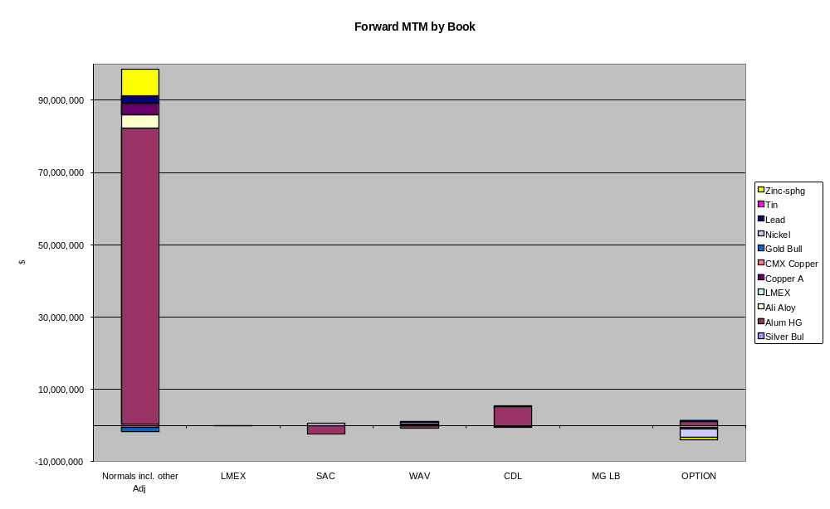
The profitable aluminium forwards make a significant portion of each book totalling approximately $85.1 million. The Option Position and SAC books were the only loss-making books.
Zinc, copper and aluminium alloy all contributed to the profitable Normals book. MTM losses have been incurred on nickel options booked to the Options book.

MTM by time period
Analysis of each book by time period was not available. However, such analysis is available for forwards and options instruments separately, which is presented below.
 | $m
Forwards | 96.4
Options | 6.2
FX and other | 9.6
 | 113.3

Analysis of Forwards
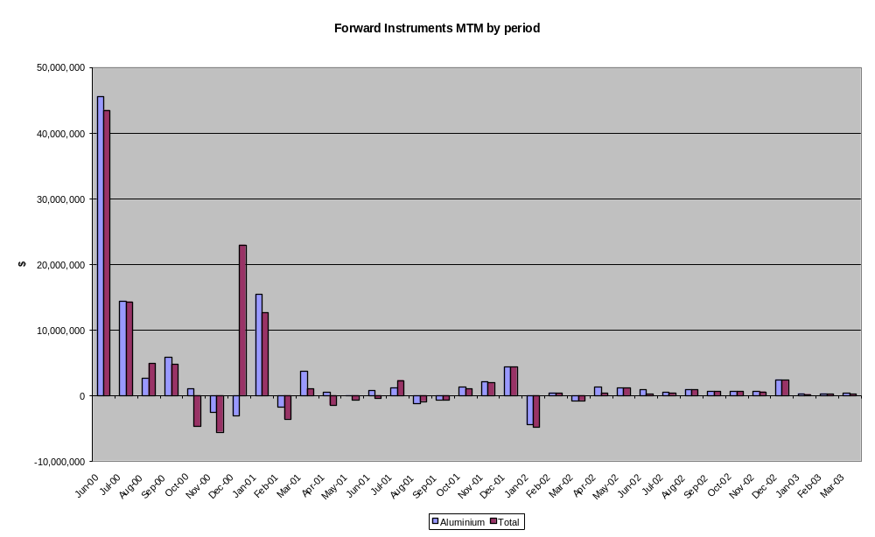
As can be seen from the chart below, the majority of value within the book is near-term, maturing by February 2001. The forward book does, however, extend out to 2003.

The primary contributor to the value of the overall forward position is aluminium. However, in September and November 2000, large LME copper positions dominate. These relate to certain trades executed with MGMCC. The total value of forward instruments at 9 June 2000 totalled approximately $96.4 million.

Analysis of Options
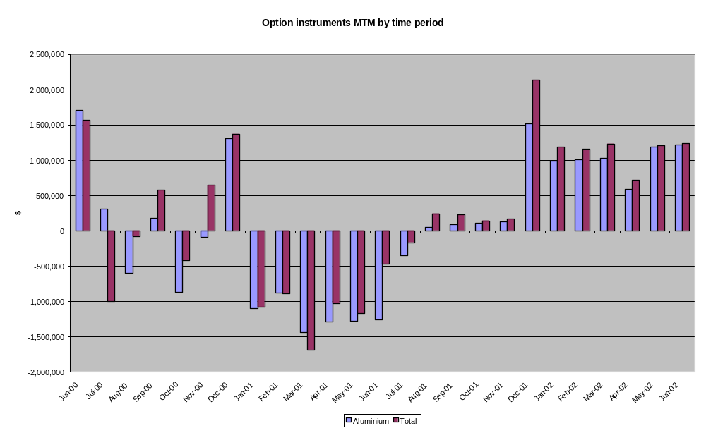
A distinct pattern in the fair value of options is evident from the chart above. Short- and long-dated options are in the money while medium-dated options are loss-making. Overall, however, MTM value of options at 9 June 2000 is $6.2 million.

Open position
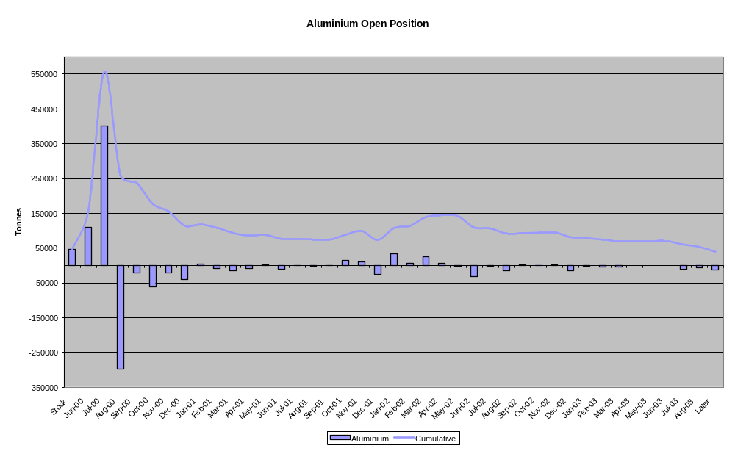
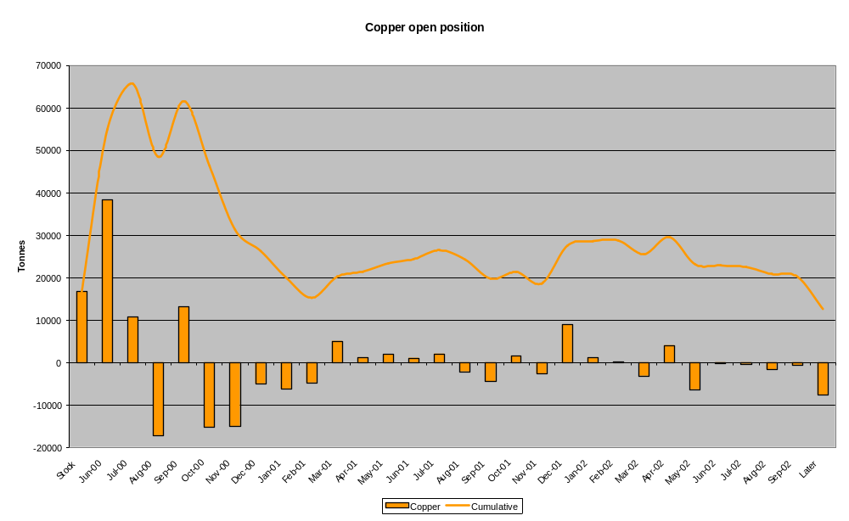
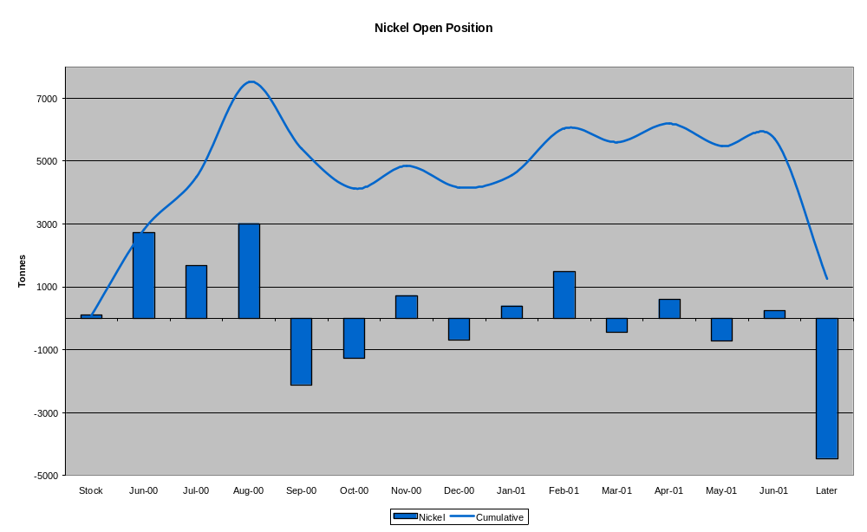
The charts above set out the 3 most significant metals by volume within MGL’s portfolio. MGL’s general strategy is not to maintain significant outright positions. However spread positions are put on which are generally long before short (when including the stock position) to take advantage of the typical contango in metal markets.

Copper is by far the primary component of forward tonnage. MGL hold long positions of copper, lead, silver and zinc in the short term, and generally short positions of longer dated forwards.

Valuation procedures
All MGL trading is in metals meeting the LME specification. As a result the MGL book is valued using the daily closing prices from the LME. Any value relating to metal which exceeds the LME specification is only recognised when realised and the forward curves are not adjusted for such ‘premium’ metal. The majority of trades in the MGL book are within the dates of the LME contracts and therefore LME curves can generally be used. Where there is a need for greater granularity than that provided by the LME prices, the company uses linear interpolation between data points. For quotes beyond the LME contract dates, the company uses linear extrapolation.
The company also downloads prices and volatilities for bullion (gold, silver, platinum, palladium) from the Rothschild pages. However the book is generally short-dated.
Volatility curves are also downloaded from the LME. For option positions beyond that range the company either uses the same volatility as the last LME date (i.e. flat volatility curve for zinc given that current position is only 3month beyond LME market tenor) or adjusts it slightly downward (0.05%/month for aluminium).
Interest rate (LIBOR) curves are also downloaded from the London Clearing House, as are foreign currency rates. The book is discounted using the LIBOR curve.

There are no other valuation reserves, other than specific reserves against credit exposure.

31 March 2000 balance sheet

Accounts receivable

Analysis of accounts receivable
AA reviewed the accounts receivable at 31 March 2000, and noted the following breakdown:

 | $'000
Trade debtors | 178,136
Owed by MG AG group | 1,818
Owed by MG plc subsidiaries | 398,138
Owed by non-consolidated group undertakings | 60
Other debtors | 9,355
Prepayments and accrued income | 20,758
 | 608,265

Of the trade debtors, $156m is the marked-to-market value of the trade debtors, derived from the Commitments List Summary produced daily; this shows both the current and forward positions with each counterparty, and produces a net position for each, either a debtor or a creditor. AA reviewed this report and noted that there were approximately 400 counterparties listed, of which approximately 25% were net debtor balances. Of these, the largest balances were an amount from the London Clearing House of $34m, ($14m forward balance and $19m current account), $12m from Amalgamated Metall Gmbh ($17m forward and $5m current account creditor), $11m from MG Ne Produkthandel (almost all forward), and $12.8m from Nissho ($18m forward and $5m current creditor).
MG Ne Produkthandel is a metals dealer owned jointly by MG and a third party. The company entered into loss-making contracts. These contracts were taken on by MG Ltd on the understanding that MG Ltd would try to reduce the losses, but would be reimbursed for any losses that the contracts did make. The maximum losses that were guaranteed to be reimbursed were $25m, and the guarantee expires at 31 December 2000. As at 9 June 2000 the losses on the contracts had been reduced to $11m, and Hamish Scutt (Credit Controller) was confident that losses in excess of the guarantee would not be made.
Nissho is a shareholder of MG plc, and MG Ltd acts as its LME broker. At 30 September 1999 (per KPMG workpapers) there was a balance of $20m outstanding from Nissho, for which there was a guarantee from Sanyo bank which was due to expire at 31 December 1999. As at 9 June 2000 a balance was still outstanding from Nisshoand Nissho had extended the guarantee. MGL also underwrote half of the amount with another bank to reduce their exposure to the Japanese market.
The company has fully provided against receivables from China Resources Natural Co of $6.1 million. The two parties have been through an arbitration process and a judgement is expected in approximately 6 weeks times. MGL has received full payment from MG AG for this debt under and indemnification set up prior to flotation of the MG plc group. The company is also fully provided against a debt of $6.7 million from Clee Overseas. Clee Overseas has a zero credit rating, and MGL only traded with them on the back of a guarantee provided by Clee’s shareholder (a major Russian company). Clee could not pay their debt and the Russian guarantor refused to meet the guarantee. The company therefore provided in full against the outstanding debtor balance. The rest is made up of $5.4m of trade debtors in Henry Bath and $13m of trade debtors in Billiton.

Credit Procedures
MGL has a formal credit policy in place. The key points for the credit approach are:
- credit limits are to cover forward market exposure only
- credit limits are not to be used to allow settlements to be deferred
- credit limits will not be increased to meet margin calls already issued
- good performance on call is a prerequisite to continuation of a credit arrangement
- senior management must always be aware of late payers and position concentrations
Prepayments and accrued income consists of accrued rental income ($12.6 million) and accrued exit fees ($4.4 million).
Credit lines are approved using a formalised process of evaluating counterparty financial statements, D& B reports, payment histories etc. These files are updated on a periodic basis. The company has recently changed its policy to reduce the frequency of evaluation for smaller counterparties to 18 months and to increase the evaluation frequency of larger counterparties to every 6 months. Credit limits are set judgementally based on the Counterparty Risk Manager’s evaluation of the credit standing of the counterparty and the amount of credit required to conduct MGL’s volume of business with that customer.
There is a daily credit review of the company’s credit exposure. Exposure includes forward MTM exposure (for LME and OTC business), any outstanding ledger balance/cash on deposit for margin, and any stock held as collateral. This is compared to the credit limit granted to the customer. Any balance over the limit is cash called from the customer. The counterparty risk manager also reviews the initial margin relative to the credit limit granted to the customer. This gives him an idea as to sensitivity of the position relative to the market moves (initial margin being indicative of the open position with the customer). There is no evaluation of potential credit risk based on stress tests or Credit Value-at-Risk (CVAR). A daily report of customers over their credit limit is prepared and circulated to the traders. This shows the amount that the company is over the credit limit by, how long they have been over their limit, and the credit mitigating actions taken. The traders have access to the credit information and this is displayed on their screens when entering a trade. However this information is limited to the credit limit, and ledger balance. There is a project in place to add extra information to this screen to allow traders to take a more proactive stance regarding credit control.
The company does not charge for initial margin for high quality clients, this being normal practice in the metals market. However there is careful review of the initial margins whether charged or not, given MGL still has to fund the initial margin to the London Clearing House on behalf of its customers.
The company also uses guarantees and letters of credit for credit enhancement. These are included within the credit limit. A separate report is generated from the system which shows the expiry date for which the guarantee applies.
For credit exposure purposes the company looks at net balances with each counterparty even in the absence of master netting agreements. There is currently no formalised process for evaluating groups of related companies to assess MGL’s overall exposure to the group – limits are set at the individual company level. There is also no formalised process for considering the consolidated exposure at the MG plc level.

Credit Concentration
There are significant credit concentrations within MGL’s portfolio, with the top 3 clients making up approximately 68% of the credit exposure. Credit exposure as of 9 June 2000 is set out below:

Client | Total commitment | %
 | ($ 000's)
Alusuisse Trading AG | 36,580 | 32%
VAW AG Bonn | 30,076 | 27%
MG Ne Produkthandel | 10,935 | 10%
Amag Metall GmbH | 6,712 | 6%
Norimet Limited | 3,891 | 3%
Mg Metals Scrap Div | 2,316 | 2%
Showa Denko | 1,719 | 2%
Falconbridge Ltd | 1,247 | 1%
J Aron & Co inc | 1,118 | 1%
Global Minerals | 1,114 | 1%
Other | 17,651 | 15%
 | 113,359 | 100%

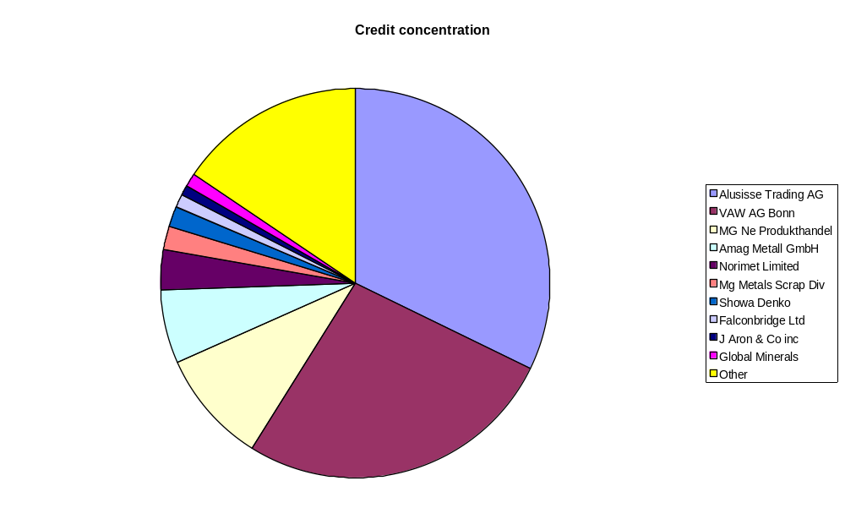
It should however be noted that while MGL has credit exposure of $113.3 million at 9 June 2000, this compares to total credit lines granted to clients of approximately $900 million. Further details of the most significant credit lines granted are presented in Appendix VI.

Stocks

Analysis of stocks
AA reviewed the stocks balance at 31 March 2000 and noted the following breakdown:

 | $'000
LME warrants | 81,414
Physical stock | 115,006
Repo stock | 356,444
 | 552,864

AA reviewed in more detail the stocks balance at 9 June 2000, and noted the following breakdown:

 | $'000
LME warrants | 32,115
Other warrants | 19,292
Physical stock | 160,073
Repo stock | 284,890
 | 496,370

Of the physical stock, the aluminium was mostly in the northern UK and also some in Sweden; the aluminium alloy was in Rotterdam; the copper mostly in Singapore; the lead mostly in Sweden and China; the cadmium in Rotterdam; and the cocoa beans mostly in Teesside and Rotterdam, and also in Avonmouth.
AA obtained confirmations from all counterparties of repo stock held by them, and vouched a sample of the physical stock to internal and external documentation (aiming for 40% coverage) requesting and gaining confirmation of selected balances to achieve coverage of approximately 44% of the stock value. The LME warrants held were reconciled to the SWORD listing at that date. For the other warrants, confirmation was sought and obtained for the gold bullion and silver bullion from the brokers; no confirmation was sought for the platinum, palladium, zinc and cocoa warrants (total MV $8.9m). Total coverage of stock balances was approximately 80%.
The company also has a large consignment of aluminium at British Aluminium (“BA”) (market value over $50m). MCC retain ownership of this stock and insure it, but BA is responsible for the physical safeguarding of it. MCC rely on BA informing them of their usage on a timely basis, at which point an invoice is raised for the amount used.

Accounts payable

Analysis of accounts payable
AA reviewed the accounts payable at 31 March 2000 and noted the following breakdown:
 | $'000
Bank loans and overdrafts | 146,985
Repo finance | 564,434
Trade creditors | 228,290
Owed to MG AG group | 1,063
Owed to MG plc subsidiaries | 44,024
Taxation and social security | 6,712
Accruals and deferred income | 27,819
Other creditors | 5,997
 | 1,025,324

Bank loans and overdrafts are all short-term loans, the largest being $70m from Barclays, $25m from Dresdner, $20m from HSBC and approximately $20m from Commerzbank. The company performs bank reconciliations on a daily basis. Reconciling items all tend to be less than 7 days old.
The repo finance creditor relates to both the repo stock held by counter-parties ($356m), and the debtor for reverse repos done with other group companies ($257m); the creditor does not match exactly as the repo transactions are often done by borrowing 90% of the stock value (to give the counterparty a margin should the value of the stock held fall), and because of interest charges included in the creditor, and other adjustments.
The company prefers to undertake repo agreements where they get 100% of the value of the stock. These tend to be with specific banks and third parties such as AIG and Cargill, and were originally ‘invented’ in order for the counterparty to avoid any credit risk of MG not being able to buy back the stock at the end of the repo period. Under these arrangements, the London Clearing House acts as a ‘wash’ for the buy-back portion of the transaction, however to classify such an arrangement as a repo, MG must ensure it buys back exactly the same stock or warrants as it sold. This is done by creating a second transaction, just prior to the buy-back at a fixed price from the LCH, with the counterparty, where MG buy the exact stock/warrant back from the third party at the market price. These transactions cannot easily be retrospectively identified as repo transactions in MG’s books. This type of repo transaction may account for half the repos at any point in time.
Of the trade creditors, $158m is the marked-to-market value of the trade creditors, derived from the Commitments List Summary produced daily; this shows both the current and forward positions with each counterparty, and produces a net position for each, either a debtor or a creditor. AA reviewed this report, and noted that of approximately 400 counterparties listed roughly 75% were net creditors. AA also noted that the gross debtors and creditors could be much larger than the net balances. The most significant of the net creditors, including large gross balances, were:
$0.2m to Alum Co of America ($5.2m forward creditor, $5m current debtor)
$12m to Alusuisse Trading AG ($118m forward debtor, $130m current creditor)
$2.2m to Norimet Ltd ($20m forward debtor, $22m current creditor)
$0.8m to Inversiones CEGA ($15m forward creditor, $14m current debtor)
$9.9m to General Electric (almost all forward creditor)
$3.2m to Hoogovens Al Trading (all forward creditor)
$2.6m to Marubeni Corporation (all forward creditor)
$5.7m to Nord Affinerie AG (all forward creditor)
$6.2m to PLM Beverage Can (all forward creditor)
$3.7m to State Regulation ($1.1m forward debtor, $4.8m current creditor)
$3.7m to Trans World Ltd LDN (all forward creditor)
$2.7m to C. Wehlen ($1.2m forward, $1.5m current)
$4.7m to Wise Metals Co Inc (all forward creditor)
$5.5m to W. & O. Bergmann (all forward creditor)

The other $50m of the trade creditors is mostly a creditor from MG LB to Credit Lyonnais Rouse for financing; per discussion with MG personnel it seems probable that this balance (approximately $35m) more correctly belongs in the repo finance creditor. The rest of the MG Ltd consolidated trade creditor balance is $17.8m of trade creditors from Billiton.

Policies and risk management procedures
The company has a formal risk management manual in place. This was prepared in connection with the flotation and was awarded ACRM (Approved Credit Risk Management) designation by the SFA in 1999. The manual specifies the responsibilities of the board, key risk committees and trading and back offices.
There is currently a risk management committee at MGL, MGMCC and MG plc levels. The primary role of the committees is to review the daily positions and compare to the limits specified within the manual. From time to time traders may wish deliberately to take positions which exceed the limits. These have to be pre-approved by the MG plc risk committee. The members of the risk committees are:
MG plc
David Tregar (Finance Director/Director of Risk)
Non-executive board directors

MGL
Tim Jones (Head Trader)
John Barret (Risk Manager & Compliance officer)
Mike Hutchinson (Chief Executive)
David Tregar (Director of Risk)
Hamish Scutt (Credit)
Russell Plackett (Head Options Trader)
Kevin Rhodes (Finance Director/Director of Operations)

Limits for MGL are set for each metal on outright volumetric position (including delta adjusted options), time spreads and option greeks. Greek position limits for gamma and theta are only for –ve values. Where limits are exceeded the company risk committee is informed with a memo describing reasons for exceedance and plan of action. Further details of the limits are set out in Appendix VI.
The MGL risk manager compare actual volumetric positions to the limits on a daily basis. A summary report of the volumetric position by metal and book is prepared and circulated daily. The risk manager also performs stress testing of the portfolio on a daily basis. These consist of price volatility shifts of 10% and 20% and there are also limits which apply to these tests. The effect of such volatility shifts is reduced by 50% in the second year and 75% in the third year. Where limits are exceeded, a report is prepared, outlining the nature and reason for exceedance and what the plan of action is.
Daily P&L reports and position analysis reports are available. These are verified with traders and reconciled to their records. We have not however seen any summary reports which analyse the reasons for the daily P&L shift (new trades, market moves, rolloff of position).

Mercur Risk Management System
The Mercur system uploads the volumetric positions from all MG plc companies on a daily basis. Individual company risk managers are responsible for reviewing that the upload was correct. Directors and management of the company have access to the system to be able to review the volumetric positions. The system also allows drill down into the daily forward positions by metal.
Outright and spread limits are monitored using the MERCUR system. The system monitors spreads for each metal in two time brackets:
- Up to 3 months; and
- Greater than 3 months
This is consistent with the periods for which maximum and average spread limits are set.
The system uses a traffic light system for flagging limit breaches:
Green : within 80% of limit
Orange: 80-100% of limit
Red : over limit
One minor limitation of Mercur is that for each period (i.e. less than 3 months or greater than 3 months) the system can only handle a situation of backwardation or contango but not a combination of the two.
The Mercur system also has a quasi-VaR engine based on historical prices. However the price history held is limited and there is no provision for taking into account correlation between different risk factors.

Henry Bath
Warehousing principally generates income from rent charged. For LME warehouses, the LME fixes rent which is paid once a year on 31 March 2000 by whichever party is holding the warrant at that date. Clearly the company’s rental income is determined by the amount of metal it is warehousing.
Over 90% of the company’s business is LME related warehousing. The largest stocks tend to be held in the UK warehouses, but Germany, the US, Singapore and Rotterdam may also be storing significant metal stocks at any point in time.
The company has recently constructed new warehouse space in Liverpool and Los Angeles.
The Henry Bath warehouses primarily store metal, but there are also large stocks of Cocoa in a UK warehouse and an element of general goods storage.

MG MCC Limited

Current Operations
MC MCC Limited is a merchanting company, undertaking the physical purchase and sale of metals, purchase and sale of warrants and sale and buy-back of inventory. It is an Associate Trade Member of the LME and participates, through MG group brokers, on the LME and COMEX.
The company principally trades in Copper, Aluminium, Nickel, Zinc and Tin.

Customer base
MCC has over 200 customers (including those out of branch offices outside the UK). Sales tend to be concentrated by metal – principally copper, nickel and aluminium, with copper contributing the highest proportion of MG MCC’s income. Geographically sales are made to the UK, USA, Chile, Russia, Korea, China and others.

Analysis of MGMCC forward book

MTM by metal
MCC runs 3 primary books: physical, LME, and FX. For each of the metals the physical position is hedged by the LME and FX books. The forward book is not currently discounted for time value of money; however due to the short nature of the book, management does not consider the effect to be large. The value of the book at 9 June 2000 may be broken down as follows:
 | $m
Physicals | (2.7)
LME | 1.8
Comex | 2.3
FX | 2.8
Total | 4.2

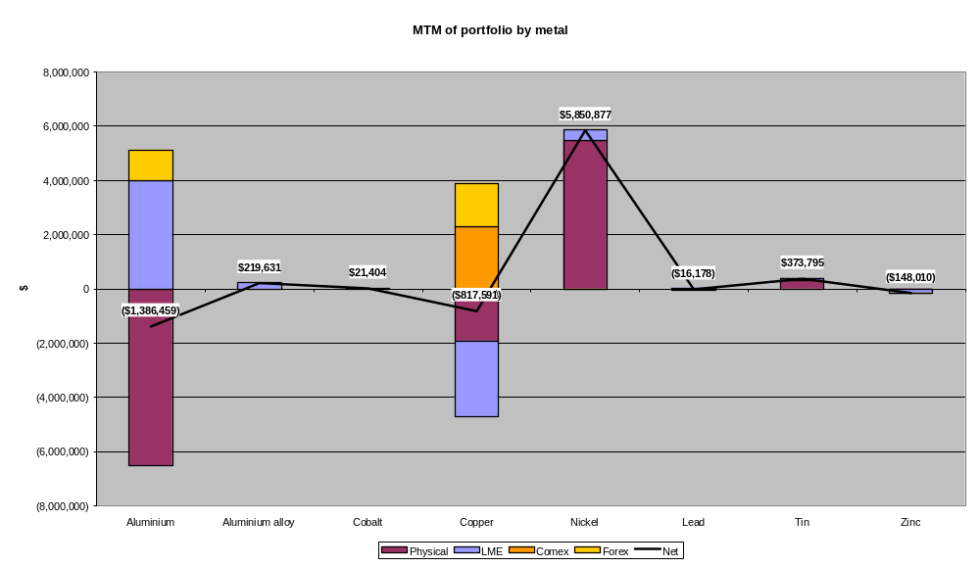
There is no significant concentration of value within any specific book except for the nickel position which is $5.8 million compared to a total book value of $4.1 million at 9 June 2000. The most significant metals are aluminium, copper and nickel. Options do not form a significant part of the book.

Forward MTM by time period
The current forward positions held by MCC extend out until December 2003, however significant positions are held only until the end of the first quarter 2001. The chart below presents the most important contributors to the forward MTM profit; copper, nickel and aluminium. As can be seen there are large swings in value of copper in December 2000 which is substantially a trade with MGL. Aluminium, while an important part of the book does not have any significant MTM value, with physicals largely being hedged with LME trades.
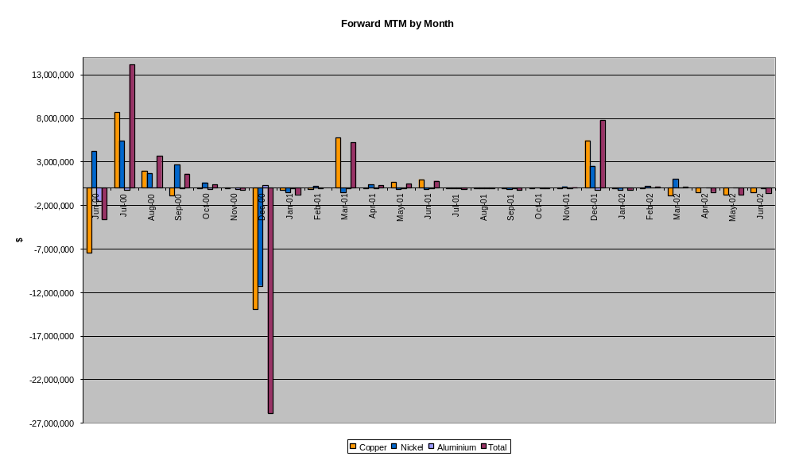
The value of the physicals book by time is also presented below, which shows the very short-term nature of the book.
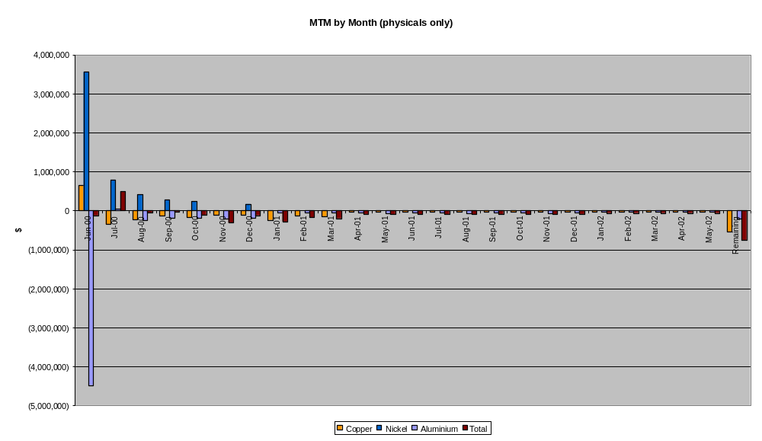

Open position by period
MGMCC’s strategy is to take positions which will be within preset limits. There is significant emphasis on time spreads, rather than outright positions. Again similar to MGL’s strategy, the company will be long before short. The most significant metals, aluminium and copper are presented below, where the cumulative position shows the long before short strategy.

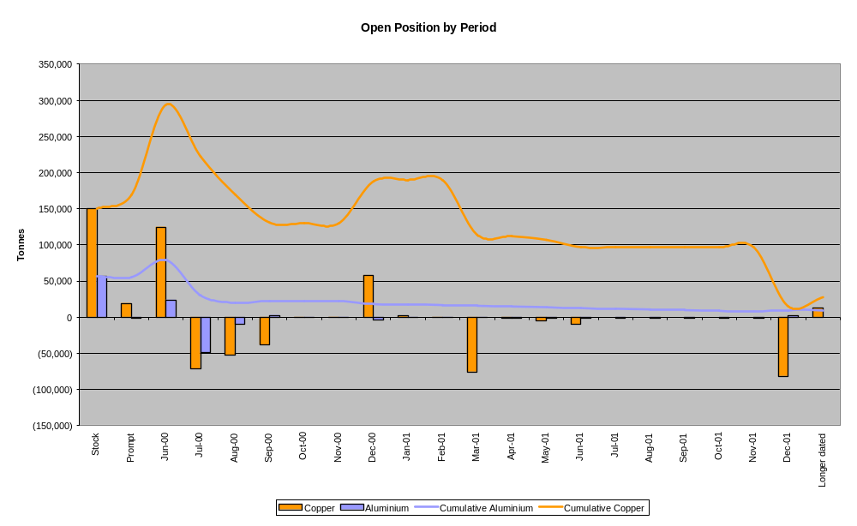

Valuation procedures
Given that the company deals in metals that do not necessarily meet LME specifications, the company uses the LME prices as a starting point. Premia or discounts are added to these prices to take into account metal specification, location and brand. These premia and discounts are provided by the traders with limited verification by risk management staff given the illiquidity. No bid ask spread is built into the valuation curves. All positions are marked to the mid-point. Additionally the position is currently not discounted for the time value of money.

Policies and risk management
The company has a formal risk management manual in place. This was prepared in connection with the flotation. The manual specifies the responsibilities of the board, key risk committees and trading and back offices.
There is currently a risk management committee at MGL, MGMCC and MG plc levels. The primary role of the committees is to review the daily positions and compare to the limits specified within the manual. From time to time traders may wish deliberately to take positions which exceed the limits. These have to be preapproved by the MG plc risk committee. The members of the risk committees are:

MG plc
David Tregar (Director of Risk)
Non-executive board directors

MGMCC
Howard Carter (CFO)
Mike Farmer (Chief Executive & Head Trader)
Thomas Buercher

Limits for MGMCC are also set in a manner similar to MGL. In addition separate limits are also specified for concentrates with fixed TC/RC charges. Generally MGMCC is only allowed to buy options.
Risk management procedures are not as formalised as for MGL. There is no overall report prepared and circulated on a daily basis which compares the actual positions against the limits. This is done informally by reviewing the information in the system. If limits are exceeded, they are discussed informally by Howard Carter and the MG plc Director of Risk. There is no formal report that is prepared.
No stress tests are carried out on a regular basis. Daily P&L reports and position analysis are available which are verified with the traders. Additionally there is no analysis of the option greeks given the limited use of such instruments by the company.
For details of MERCUR capabilities, see section [5.6].

Balance sheet at 31 March 2000

Accounts receivable

Analysis of accounts receivable
AA reviewed the accounts receivable balance at 31 March 2000 and noted the following breakdown:

 | $'000
Trade debtors | 129,970
Owed by MG AG group | 1,490
Owed by MG plc subsidiaries | 164,599
Owed by non-consolidated group undertakings | 1,999
Other debtors | 176
Prepayments and accrued income | 911
 | 299,145

The majority of the trade debtors balance, $115m, is derived from the debtors and creditors listing from AS400. AA reviewed this report and noted that there were approximately 150 debtor balances, of which 2 were over $10m: $13.3m from Boliden Mineral and $15m from Straits Resources, and another 3 were over $5m. The majority of the debtors were under $500k. The other significant trade debtor balance was $18m of mark-to-market adjustments on the forward debtor positions.

Credit control
Over 40% of MCC’s deals are settled by cash, but for the others credit limits are established for each customer, as follows. Credit terms are normally 30 days, but can be up to 60 days for large customers, particularly those in Germany. The general process for credit at the MGMCC level is similar to MGL. However it is less formalised. For instance there is overall credit policy governing such operations. Also the reports generated for monitoring credit exposure focus more heavily on the ledger balances given the merchanting nature of the business where there are more likely to be disputes and delays in collection.
The primary tools are a daily report comparing overall credit exposure and credit limits. Credit exposure is defined as the outstanding ledger balance, deferred payments and MTM of physicals. In addition a spreadsheet is prepared daily which shows balances that are overdue.
The trader negotiating the transaction applies to the credit controller, Alan Jamieson, for a credit limit. Alan refers to financial statements and other information about the customer, and can grant credit up to $250k himself. Limits up to $4m can be granted by the MCC board, and above that by the MG plc board. Once approved, the limit stands on the system. The limits of active customers, and any current or forward credit exceeding that limit, are shown on the Daily Exposure report, produced and reviewed every day by the credit controller. There are currently approximately 280 credit lines standing, of which approximately half are active; the inactive lines are reviewed at least every 6 months by the credit controller.
It is possible for a trader to enter into a deal that puts a customer over their credit limit, however this is highlighted on the Daily Exposure report. AA reviewed this report at 31 March 2000 and noted that there were several balances in excess of credit limits.
From the Daily Exposure report (which shows overdue, current and forward balances), the credit controller extracts all overdue balances over $100k and puts them, with details and comments, onto a memo which is circulated to the Finance Director, the traders, and the shipping department. AA reviewed this memo for 31 March 2000 and noted that there was a total of approximately $6m overdue at that date, but that no balance was more than 8 days overdue, and most were only one day overdue.
Per discussion with the Finance Director and the credit controller there have been only 3 or 4 bad debts in the last 10 years. Last year there was one for approximately $100k. No general bad debt provision is maintained given the low occurrence of bad debts.
Credit concentration as of 9 June 2000 for MGMCC were as follows (all counterparties with commitments over $2 million):

Client | Total commitment (USD 000's)
Barclays | 30,794
Straits | 15,020
Boliden | 9,417
Alcan Corp | 5,666
Colata | 4,712
Shang Ind | 3,900
British | 3,822
Kemper | 3,300
Scottsboro | 3,298
Encore | 3,043
Alle Tele | 2,881
ALCOA EXTR | 2,759
Noranda | 2,739
Wells Al | 2,424
BICC | 2,381

Stock

Recording of stock information
Stock information is provided to the shipping department, in the form of bills of lading, warehouse releases, or other documentation showing that title to the stock has passed. The shipping department use the AS400 system to see what stage stock is expected to be at, and on what day title should be passing. Some spreadsheets are also used to record the information, however exclusive use of the AS400 system is being encouraged, as programmes designed within it enable all information to be stored on the system. When the shipping department decide that title has passed, they process the purchase invoice (if a purchase) or create a sales invoice, all using the AS400 system. On processing or creation of invoices the system automatically updates the stock, long/short position, and debtor/creditor information.

Analysis of stocks
AA reviewed the stocks balance at 31 March 2000 and noted the following breakdown:

 | $'000
Held as own stock | 398,948
Held by third parties under repo transactions | 338,607
Held by MG plc group companies under repo transactions | 256,999
 | 994,554

The stock balance at 9 June 2000 was reviewed in more detail. As an overall valuation of stock at that date was not available from the MG MCC personnel, AA constructed the balance with their help, and it is this balance that is analysed here. AA noted the following breakdown at that date:

 | $'000
Held as physical stock | 432,870
Held as LME warrants | 21,560
Physical stock held under repo transactions | 283,575
Warrants held under repo transactions | 203,861
 | 941,866

The physical stock is held in warehouses and in transit around the world (see Appendix V). AA requested and obtained confirmations from holders of this stock which covered approximately 25% of the value of this physical stock.
The warrants held as stock are held by MG Ltd on MG MCC’s behalf, and are listed under SWORD under their name. All warrants were agreed to the SWORD listing.
Warrants held under repo agreements were agreed to confirmations from counterparties. Warrants under repo transactions were held by 3 counterparties, the largest balance being held by AIG Ltd of $102.3m (Fimnet $75.7m and SocGen $25.9m). Physical stock held under repo agreements was also agreed to confirmations from counterparties; it was held by 4 counterparties, the largest balance being with Barclays of $147m (Commerzbank $104.5m, BNP $30.8m and CRLY $0.7m). All repo stock was valued at market values.
AA’s objective was to get 40% coverage of the total stock at MCC, however we obtained coverage of approximately 65% of the total stock balance at 9 June 2000. No exceptions were noted.

Accounts payable

Analysis of accounts payable
AA reviewed the accounts payable balance at 31 March 2000 and noted the following breakdown:

 | $'000
Bank loans and overdrafts | 336,736
Repo finance | 333,994
Trade creditors | 86,320
Owed to MG AG group | 289
Owed to MG plc subsidiaries | 522,473
Owed to non-consolidated group undertakings | 26
Taxation and social security | 1,965
Accruals and deferred income | 8,677
 | 1,290,480

Bank loans and overdrafts
These loans were all short term, taken out with various banks to fund short term positions. There were 8 loans, the largest of which were $125m with Barclays Capital, and $88m with BBI. Bank reconciliations are performed on a daily basis. Reconciling items tend to be less than 7 days old.

Repo finance
MG MCC regularly sell stock to banks under “repo” agreements, whereby a sale contract and a purchase contract are made at the same time, for the same quantity of stock. This is bought by the bank at a named price, on a certain date and sold back to the company for a slightly higher price, usually about a week later.
The purpose of this is to help the cashflow of the company. To reflect this the price differential is charged as interest, and included in Cost of Sales as a trading cost. The AS400 system recognises the transaction as a sale and then a purchase (these are reversed on consolidation), but in order to comply with UK accounting standards the stock must be brought back onto the balance sheet. There is, therefore, both a stock balance (see Stock section for discussion), and a repo creditor in relation to this stock.
The balance of $334m included in creditors above does not match exactly, but is close to, the amount of repo stock included in the stock balance of $339m. The creditor does not match exactly as the repo transactions are often done by borrowing 90% of the stock value (to give the counterparty a margin should the value of the stock held fall), and because of interest charges included in the creditor, and other adjustments.
MG MCC perform detailed calculations in order to bring the stock held under repo transactions back onto the balance sheet. AA noted that MG MCC and MG Ltd appear to use a different calculation methodology for this, but was not able to quantify exactly what the difference in method was or to quantify what the effect might be.

Trade creditors
The majority of the trade creditor balance, $61m, is derived from the debtors and creditors report produced by the AS400 system. AA reviewed this report and noted that there were approximately 175 creditor balances, of which 5 were over $5m ($11.5m to BNP Bank; $7.5m to Commerzbank; $9.9m to Hudson Bay, Canada; $5.2m to Noranda in Canada; and $5m to Atlantic Copper). There were a further 5 balances over $1m, and the vast majority were below $500k.
The other significant trade creditor balance was $23m of mark-to-market adjustment on the forward creditor positions.

MG MCC Corp.

Organisation and Business

History
MCC Corp was formed in October 1996 as part of a merger between Ore and Chemical Corporation (“OCC”) and Metal Concentrates International Inc. (“MCII”). The principal business of OCC was the trading of metals, alloy and latex. The principal business of MCII was copper concentrates trading. MCII had suffered a loss in 1995 of $40 million prior to the merger. The former president had taken significant long physical positions and had significant spread positions that the company failed to hedge. Upon resignation, the president pursued legal action against the Company, as in section 7.8..
Subsequent to the merger, several of the product operations were spun-off. In addition, the primary aluminium trading business (LME deliverable) was transferred to London in February 2000.
MCC Corp is based in New York and has offices in Chicago and St. Louis. The trading of copper concentrate, as well as all of the corporate functions (maintenance of the books and records, treasury, payroll, etc.), are maintained in the New York office, which has approximately 60 personnel. The Chicago office trades aluminium scrap and has approximately 10 personnel. The St. Louis office trades copper scrap and has 4-5 personnel.

Current Operations
MCC Corp is a wholly owned subsidiary of MG Trade Holdings, Inc. (the “Parent”), which is ultimately a wholly owned subsidiary of MG plc.
The primary businesses of the company are (1) copper concentrates trading, (2) aluminium scrap trading, (3) copper scrap trading, (4) zinc trading and (5) agency trading.

Copper Concentrate Trading
($256 million of total $506 million revenue to 31 March 2000)
Copper concentrate trading is the primary business of the company in terms of sales. Copper concentrate trading involves purchasing concentrate from mines and selling the concentrate to smelters. The forward contracts may be classified as either spot, fixed or frame contracts. Spot contracts are typically effective for up to six months and are negotiated with the current prevailing market terms. Fixed contracts are typically effective for six to twelve-month periods and are written to take into account long term changes in the market. Frame contracts can extend for several years but have terms that are negotiable (typically on an annual basis).
Pricing is determined using the LME and COMEX adjusted for TRC credits. As the company generally has a buyer in place by the time it accepts delivery, it does not hold inventory positions of copper concentrate.
Customers include LG Nikko (South Korea), Birla Industries (India), and Yantai Penghui (China). Suppliers include BHP Group, Kennecott (Utah), and Phelps Dodge (Arizona).

Aluminium Scrap Trading
($203 million of total $506 million revenue to 31 March 2000)
Involves the trading of non-primary aluminium, including canned sheets, class 1 and 356 aluminium. The typical forward contract is for three months but may extend to six or twelve months. Suppliers include AS Industries (Russia), Alcoa and Reynolds. Customers include Alcan and Hydro Aluminium. Aluminium scrap trading generally accounts for the company’s entire inventory at any time.

Copper Scrap Trading
($4 million of total $506 million revenue to 31 March 2000)
Involves the trading of non-primary copper. Similar to aluminium trading, the typical forward contract is for three months but may extend to six or twelve months.

Zinc Trading
($5 million of total $506 million revenue to 31 March 2000)
Involves the trading of zinc.

Agency Business
($38 million of total $506 million revenue to 31 March 2000)
Involves aluminium, copper and zinc trading where the company is acting as agent rather than principal. The company earns a commission of $5 per ton.

Related Parties
The company disclosed to us the following related parties and dealings:

MG Limited - has entered into repurchase transactions with the company in the past (none outstanding at 31 March 2000).

MG London Inc. - Serves as a brokerage for forward contracts, earning commissions. MG London Inc. provides the Company with financing for operations. The company had $11.5 million due to MG London Inc. at 31 March 2000.

MG Metal & Commodity Limited - The company functions as agent for MG Metal & Commodity Limited (“MGMC”), earning commissions. The company also borrows and lends money from/to MGMC. As of 31 March 2000, a portion of the $58 million facility that the company had outstanding from Barclays had been lent to MGMC.

MG Central Services, MG Corp, Sachtleben - Represents companies that continue to share office space and certain services with the Company. As a result, there exists a process of reimbursements and chargebacks.

Henry Bath, Inc. - gets charged a tax allocation because it is using some of the company’s net operating loss.

MGAG Technologies (formerly MG Trade Services AG) - The Company had various receivables due/from MGAG Technologies. The receivables included approximately $700,000 due to arbitration settlement and other receivables related to the flotation.

MG Metal and Commodity Canada - The company will provide certain administrative services (contract administration, accounting, payroll, treasury etc.) to MG Metal and Commodity Canada for a fee.

Business Risks

Supplier and Customer Credit Risk
Copper concentrate trading involves purchasing concentrate from mines, less a credit for treatment charges and refinement charges (“TRC”) to refine copper concentrate into copper cathode, and selling the concentrate to a smelter less a credit for TRC. The TRC credits are negotiated amounts based on prevailing market conditions and are exposed to changes in market conditions and volatility.

Country/Counterparty Credit Risk
The risk that counterparties will default on their obligations. Most of the company’s counterparties are international entities. The majority of the mines are located in Chile, Argentina, Peru and New Guinea. Smelters are located in India, China and Korea. To counter credit risk, the company requires letters of credit for counterparties that are deemed to have excess risk.

Market Risk
The risk that changes in the metals market may adversely impact the company. The company exposes itself to market risk upon entering into its buy and sell contracts. Although the company attempts to minimise its risk by matching deals (on an aggregate basis), the company will at any time have open and unmatched buy and sell commitments.

Financial Analysis
MG MCC Corp’s financial statements as of 30 September, 1999 and 1998, and for the years then ended, were audited by the New York office of KPMG, LLP, who issued an unqualified opinion. KPMG, LLP did not issue a separate letter of management recommendations for the company.
We performed an analysis of the 31 March 2000 trial balance. The analysis, detailed by account, is as follows:

Cash
The company had a net $356,000 overdraft balance at 31 March 2000, included within the bank loans and overdrafts amount of $58,606,000.
The company has three cash accounts: a demand deposit account and current account at Chase in New York, and a current account at Northern Trust in Chicago.
The demand deposit account at Chase in New York is used for wires and funds the current account. The company is able to monitor the account through a direct link with Chase and it is reconciled on a daily basis. The account had a balance of approximately $496,000 at 31 March 2000 with no reconciling items.
The current account at Chase is funded through the demand deposit account. The account had an overdraft balance of approximately $869,000 at 31 March 2000. Reconciliations are compiled monthly by the treasury department. We reviewed the 31 March 2000 reconciliation, noting the balance per bank to be $0 and total outstanding cheques to be $865,000.
The current account at Northern Trust in Chicago serves as the Chicago office’s petty cash account. The account had a balance of approximately $7,000 at 31 March 2000, per review of the reconciliation (prepared monthly).

Accounts Receivable
Accounts receivable was approximately $98,181,000 at 31 March 2000, compared to $72,668,000 at September 30, 1999. The detail of the balance at 31 March 2000 is as follows:

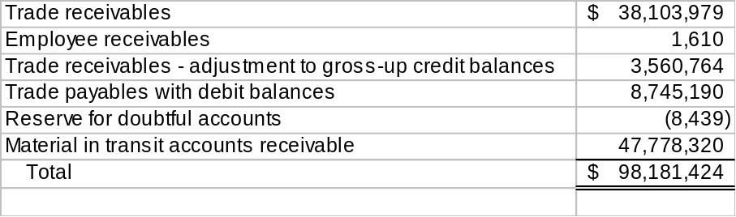
Per examination of the ageing analysis compiled for the trade receivables balance of $38,103,979, $31,414,275 had been outstanding for less than 30 days, $6,209,599 between 31 and 90 days and $480,105 over 90 days. The largest trade receivable from a single customer was $4,723,052. The combined balances of the 10 customers with greatest amounts due comprised approximately 76% of the total trade receivable balance of $38,103,979.
The allowance for bad debt was approximately $8,000 at 31 March 2000, down from $288,000 at 30 September 1999. Per L. Colarusso, the Company has not had to write off any amount during its three-year existence. He asserted that the allowance has been reduced to reflect the excellent collection history.
Material in transit accounts receivable represents transactions that have been delivered (title has passed) but have yet to be invoiced. Upon invoicing, the provisional price is finalised and material in transit accounts receivable is reclassified into trade receivables.
Per L. Colarusso, there are no concentration limits on customers that would limit risks from individual customers and/or groups of customers.
The payment terms for aluminium are typically net 30 (due 30 days after billing). Copper concentrate payment terms vary widely.

Marketable Securities
Marketable securities are composed of U. S. Treasury Bills pledged as margin deposit at COMEX for MG London. Marketable securities were approximately $2,861,000 at 31 March 2000, up from approximately $2,668,000 at September 30, 1999.

Inventory
Inventory at cost was approximately $43.6 million at 31 March 2000, compared to $70.5 million at 30 September 1999. L. Colarusso attributed the significant decrease in inventory to the spin-off of the primary aluminium and copper business to London. The unrealised gain on inventory at 31 March 2000, approximately $3.3 million was included within the unrealised gains on forward contracts amount of $41 million.
Inventory at 31 March 2000 consisted solely of physical aluminium scrap, valued at market value. Sales are recorded when transfer of ownership occurs. The contract delivery terms differ from contract to contract but the most common delivery term is FOB shipping point.
The inventories are generally held at 20-25 various third-party warehouses in the North America. The company performs due-diligence reviews of warehouses periodically and receives monthly statements from each warehouse. The company reconciles the inventory per book to the warehouse record semi-annually. Per L. Colarusso, there are usually small true-ups resulting from the reconciliation process.
We obtained the Inventory Report as of 9 June 2000 and noted that the inventory balance at cost was approximately $26 million.
The Inventory Report list inventory by commodity grade, contract number, quantity, amount and supplier’s name. From the 9 June 2000 inventory report, we randomly selected 10 contracts and requested detail. We were provided with Contract Ledger Print Reports, which lists all purchase and sell transactions and invoice numbers. We then traced the purchase/sell transactions to the actual invoices and noted agreement.
We did not confirm or verify inventory with independent parties at 9 June 2000 due to time constraints.

Unrealised Gains on Forward Contracts
Unrealised gains on forward contracts were approximately $41,015,000 at 31 March 2000 and $44,974,000 at 30 September 1999.

Property and Equipment
Property and equipment, net of accumulated depreciation, was $152,000 at 31 March 2000.

Due to/Due from Parent and Affiliates
Accounts receivable and accounts payable from/to MG plc subsidiaries relates to the due to/from broker affiliates in London. They are recorded gross, meaning that mark-to-market gains are recorded as receivables and mark-to-market losses are recorded as liabilities. As of 31 March 2000, accounts receivable from MG plc subsidiaries consisted of a cash debit balance of $0.7 million and forwards and mark-to-market gain of $1.4 million. Accounts payable to MG plc subsidiaries consisted of a cash credit balance of $12 million and mark-to-market gains on LME contracts of $7.7 million. The net mark-to market gain on LME contracts of $9.1 million was split between receivable and payable based on counterparty.

Accounts Payable, Accrued Liabilities and Other
Bank loan payable – As of 31 March 2000, bank loans payable totalled $58 million with Barclay, of which $50 million is part of a $250 million multi-currency unsecured revolving credit facility entered into by the company and certain affiliates. In addition, MG London entered into a line of credit of $15 million with Barclay on behalf of the company. The balance as of 31 March 2000 is $8 million. The interest on both loans is LIBOR plus 75 points.
Loan Payable to MG plc subsidiaries – Per L. Colarusso, this is an operating loan from the Parent. This related party loan bear a interest of LIBOR plus 25 basis points. As of 31 March 2000, the balance of the loan to MG plc subsidiaries is $11.5 million and has been subsequently paid down.
Accounts Payable
Accounts payable was approximately $65.5 million at 31 March 2000, compared to $39 million at 30 September 1999. The detail of the balance at 31 March 2000 is as follows:

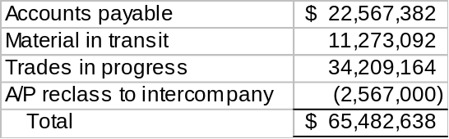

Per examination of the accounts payable vendor balances report compiled for the trade payable balance of $22.5 million, advances to suppliers totalled $18 million. The three largest vendors comprised 90% of the total advance to suppliers. Trades in progress represent the provisional invoices that had not been settled for final prices and had increased from $8 million as of 30 September1999 to $34 million. The $2.6 million debit balance accounts for payable intercompany is due to the effect of timing differences between London and the company, as different exchange trading windows are used to price the trades by the company and by the London counterparties. This intercompany difference has been cleared subsequently.
Material in transit represents transactions that have been received (title has passed) but have yet to be invoiced. Upon invoicing, the provisional price is finalised and material in transit is reclassified to accounts payable.

Unrealised Losses on Forward Contracts
Unrealised losses on forward contracts are recorded for as liabilities, and the balance was increased from $17.2 million as of 30 September 1999 to $22.8 million. Per L. Colarusso, a component of this amount is a valuation reserve of $1.5 million, which is maintained for open positions.

Accrued expenses
As of 31 March 2000 the accrued expenses were $4 million which consisted of bonuses $2.5 million, general expenses of $1 million, freight of $.4 million and audit fee of $.1 million.

Operations
The Company has offices in New York and St. Louis.

Trade Accounting
The trade support staff for each of the trading desks (copper concentrate, aluminium scrap and copper scrap) is responsible for trade accounting, including the recording of each trade’s execution and clearance. The aluminium scrap and copper scrap desks are in the process of updating their systems from Wang to AS400. The migration is ongoing as the desks are currently running the two programs simultaneously.
Plans have been made to replace the copper concentrates system, Aquarius, with AS400. The plans are in a preliminary stage and have not been formalised.

Corporate Accounting
The Corporate Accounting Group includes M. Parra, L. Colarusso, and F. Mastromatteo. The group is responsible for all areas of corporate accounting, including the booking of trades and financial reporting.
SAR, the accounting package, was installed during the latter half of 1996. Per F. Mastromatteo, the company believes that the package is still effective and there are no current plans to invest in an upgrade.

Treasury Group
Harry Zlotnick, who reports to M. Parra, heads the Treasury Group. The Group handles all transactions involving the transfer of cash and performs either daily or monthly reconciliations for all of the cash accounts.

Risk Management
The company’s management has developed a control environment and risk management strategies which analyse the company’s positions and exposures on an ongoing basis. The company’s risk profile is reviewed monthly by the Risk Assessment and Advisory Committee. A number of reports are circulated to management on a daily, weekly and monthly basis. The principal reports include daily market cards and position reports for aluminium and copper concentrate, daily trader reports which show the previous day’s trades, daily “flash” reports which show the previous days profit and loss accounts, daily “forward book value” reports which show the valuation of forward copper and aluminium positions, weekly accounts receivable reports and letter of credit status reports and monthly management packages.

Market Risk Management
Trading positions and related market risk management are monitored and managed by the local office. Andreas Barschkis in Corporate Development is responsible for all aspects of daily copper concentrate risk management and group risk reporting via MERCUR, the risk management system. At an operational level, L. Colarusso prepares the daily aluminium division risk management reports. The outright and spread copper and aluminium positions of the company are included in the position limits allocated to the company. Additionally, the company established a long and short TRC position limit of 450,000 tons and 100,000 tons, respectively. These positions are primarily monitored on a commodity basis by using the reports outlined above.

Credit Risk Management
The company employs a part-time credit risk officer to manage its credit risk. This individual is responsible for the preparation of all initial and ongoing credit reviews, the review and circulation of aged debtors reports on a monthly basis and monitoring of credit exposures against limits. After credit line approval, credit lines are reviewed again at least annually. The company has established authorisation requirements for credit approval levels. In selling copper concentrate to smelters, the company insists on the provision of a letter of credit from an acceptable bank to mitigate its credit (and country) risk. Although the use of such letter of credit may reduce the company’s customer credit risk below the level for which MG plc approval is required, MG plc is still consulted about such trades prior to the company being contracted.

Commitments and Contingencies

Buy and Sell Forward Commitments
The company enters into buy and sell forward commitments for all of its physical activity. Buy and sell contracts for the trading of aluminium and copper generally have a duration of three months. The contracts will occasionally extend to six or twelve months. Buy and sell contracts for copper concentrate may be classified as either fixed or frame contracts. The terms of fixed contracts are set forth in advance and are typically effective for one-year periods. Frame contracts can extend for several years but have terms that are negotiable (typically on an annual basis).

Employee Benefit Plan
Per M. Parra, Enron has addressed the defined contribution savings plan (“401k plan”). The plan participants will most likely be transferred into Enron’s plan.

Lease Commitments
The company entered a month to month sublease agreement with MG Corp. that leases part of the 28th floor of 520 Madison Ave. The rent and occupancy costs are allocated to the company monthly.

Debt Covenant
Per M. Parra, covenants relating to the company’s financing, including the $50 million revolving credit agreement with Barclay, are maintained at the consolidated MG plc level.

MG Trade Services (India) Pvt, Ltd.
MG Trade Services (India) Pvt. Ltd. (MG India) is a wholly owned entity of MG Trade Service AG (MGAG). It is a local India company that serves as an agent for the company and receives a monthly agency fee. As of 30 September 1999 MG India’s equity was approximately $60,000. The company has expressed an interest in acquiring MG India from MGAG for its book value. However, based on discussion with M. Parra, this matter is in discussion stage only and no option, commitments or letter of intent to acquire MG India exists.

Legal Matters
The company was named as a defendant in an employee contract arbitration claim. At the time of MG plc’s flotation on the London Stock Exchange (30 September 1999), MGAG Technologies, the former parent of the company, agreed to reimburse the company for any out-of-pocket expenses relating to this claim in order to remove any contingencies attached to the company from this matter. The case was settled in early 2000 against the company. As a result, the company paid the defendant $700,000 and recorded a receivable from MGAG Technologies. The amount is booked as an account receivable from MGAG subsidiaries.

SFAS 133
Management of the company believes that the company will not be materially affected by SFAS 133, Accounting for Derivative Instruments and Hedging Activities, as the companies’ inventory is marked to market. SFAS 133 is to be effective for fiscal years beginning after 15 June 2000.

MG London Inc.
MG London Inc. is a wholly owned subsidiary of MG Trade Services Holdings, Inc. whose ultimate parent is MG plc. MG London is registered with the Commodity Futures Trading Commission as a Futures Commission Merchant (FCM), and Commodity Trading Advisor (CTA) and is a member of the National Futures Association. It has an inactive subsidiary (a shell company with no capital) MG Trade Services Inc., which is a commodities introducing broker (IB), commodity pool operator (CPO), and CTA. MG London is a member and clearing member of the New York Mercantile Exchange (NYMEX) and Comex. The company’s primary purpose is to clear trades on U.S. futures markets for its affiliates-MG-MCC, MG Metal & Commodity Ltd., MG Ltd., and Henry Bath, Inc. It also has one customer omnibus account for MG Ltd customers and non-customer accounts.
The company’s revenues are derived from commissions, management fees and interest. Commissions charged range between $9-$13 per round turn trade. Management fees were earned from an offshore commodity fund, MG Metals Fund, for which it acts as investment advisor (CTA). Management fees are not currently being charged as the Fund no longer has outside investors due to poor performance. The company has a facilities management fee arrangement with a company, Rolf & Nolan, to support its activities as an FCM.
NYMEX acts as MG London’s designated self-regulatory organisation (DSRO). NYMEX performed a routine limited scope audit as of 31 August 1999 that had no material findings. A full scope audit by NYMEX as of 31 October 1998 disclosed no material findings. Matters cited related to maintenance of updated NFA information, segregated acknowledgement letter, submission of weekly segregation reports and maintenance of updated web site. KPMG, LLP’s report on internal accounting control, which is required by the CFTC, disclosed no material inadequacies for the year ended 30 September 1999.
The year ended 30 September 1999 and 1998 certified audit by KPMG LLP was unqualified. The auditors’ report emphasised that the entity has significant related party transactions. These items included:
- Commission and management fee revenues
- Expense allocations-rent, MIS, human resources
- Expense allocation for services provided by affiliates-financing, accounting, management, tax and administrative services
- Subordinated debt and related interest expense
For the year ended 30 September 1999 revenues totalled $5.8M consisting primarily of commissions of $3.6M and interest income of $1.4M. Expenses of $3.5M were composed of employee compensation and benefits of $1.4M and interest expense of $1.1M. Net income was $1.2M and book equity (exclusive of subordinated borrowings) was $11.6M at 30 September 1999.
As a FCM, MG London is subject to minimum net capital requirements that require it to maintain certain levels of liquid capital. At 31 March 2000 MG London had net capital of $16.5M which was $16.3m in excess of CFTC requirements. Excess net capital is maintained in the entity to support clearing level requirements at the COMEX. Included in regulatory capital is a subordinated loan of $20M from an MGAG subsidiary, MG North America Holdings Inc., which matures 1 August 2002. Interest is at LIBOR.
MG London’s activity of trade clearance may expose it to off-balance sheet risk in the event that an affiliate or customer is unable to fulfil its contractual obligation. MG London seeks to control the risks associated with these activities by requiring affiliates and customers to maintain margin collateral in compliance with various exchange and internal guidelines.

Henry Bath, Inc.
Henry Bath Inc. (HBI) operates London Metal Exchange (LME) approved warehousing facilities and general goods warehousing in the U.S. HBI leases warehouses in New Haven, CT, Los Angeles, CA, and New Orleans, LA. HBI has no employees and outsources its warehousing and administrative requirements. During March 2000 the accounting responsibilities for this entity were transferred from MG-New York to a local accounting firm in Los Angeles (Hines & Jones). Approximately 95% of HBI’s revenues are from MG affiliates.
KPMG, LLP issued an unqualified report on HBI’s financial statements for the years ended 30 September 1999 and 1998. Revenues for the year ended 30 September 1999 totalled approximately $6.3M consisting primarily of rental income of $5.3M and handling income of $0.9M. Expenses totalled $3.7M, which includes SG&A of $2.8M. Net income was $1.5M. HBI’s equity was $3.5M at 30 September 1999.
Rental income is accrued on a monthly basis. Exit fees for metal storage are payable to HBI when customers remove the metal from the warehouse and are recorded at the time of removal (US -UK GAAP adjustment). HBI leases warehouse space and equipment under noncancellable lease agreements expiring at various dates through 2003. Future minimum rental payments, net of a sublease agreement, were $3.7M as of 30 September 1999.

Commitments and contingencies

Guarantees
MGL has obtained a guarantee against amounts related to exchange traded metal contracts up to US$25.0 million payable to it by a company in which the Metallgesellschaft AG Group is a significant shareholder. The guarantee expires on 31 December 2000.
The group settled with Michael Mason in early 2000 (see section 7.8). He was awarded approximately $700k under his unfair dismissal claim, and MG plc has recorded a related party receivable for the $700k from MG AG. We understand that MG AG has not yet confirmed that it will repay these amounts.
MG AG has also charged MGL and MCC Limited ($300k and $500-600k respectively) for guarantees provided by AG on their behalf. These companies were not expecting these charges and have not accrued for them (you should consider this in the purchase price adjustment).
At 30 September 1999 the group's bankers had issued guarantees of US$202.5 million and letters of credit of US$13.8 million on behalf of the group. The group has provided the banks with indemnities against these guarantees and letters of credit which were issued in the normal course of business.
A syndicate of banks granted a secured $250 million facility (fully drawn down) to the group. The security over this loan is in the form of cross-guarantees and, for MGL which cannot give cross guarantees for regulatory reasons, by a mortgage held by the syndicate group over MG Limited’s share capital.
This loan must be repaid in full prior to Enron’s acquisition of MG plc, due to a change of control clause under the loan terms.

Forward commitments

Dividend payable
MG plc have announced a dividend payable of £14.1 million on acceptance of the recommended cash offer by Enron. This dividend had been reflected in 31 March results.

Lease commitments
There are commitments at each balance sheet date in respect of forward metal, foreign exchange, option, futures and interest rate contracts entered into in the normal course of business which are marked to market in the accounts.

Lease commitments for premises are as follows:

Company name | Term of lease | Annual basic rent
MG Limited | 25 years from 29 September 1993 | [£208,550]
MG MCC Limited | 25 years from 24 June 1993 | [£212,450]
MG MCC Corp | Expires 30 September 2000 (unless extended as allowed under the lease term) | [$644,763]
MG London Inc | As for MCC Corp | [$161,274]

Long-term contracts
There are three directors of MG plc who have two year employment contracts which are currently expected to be swapped with long-term Enron contracts.

Litigation
Codelco claim – extracted from the financial statements
MGL, together with Metallgesellschaft AG, is subject to a claim in the High Court of England and Wales by the Chilean state enterprise Corporacion Nacional del Cobre de Chile (""Codelco''). Codelco alleges that it was induced to enter into a number of metal contracts with MGL during the period from January 1990 to January 1994 as a result of an alleged bribe of US$1.5 million allegedly paid by Metallgesellschaft AG to a staff member of Codelco. Codelco is seeking an inquiry into, and where appropriate rescission of, the relevant contracts and claiming, inter alia, the return of approximately US$13.5 million of premiums and losses paid to Metallgesellschaft AG pursuant to the relevant contracts together with interest. The case is vigorously disputed by Metallgesellschaft AG and MGL on the basis that they were not involved in any payment of an alleged bribe and did not take inappropriate advantage in the context of the relevant business transactions. Metallgesellschaft AG has indemnified MGL against any loss suffered in respect of the Codelco claim and has agreed to waive all rights to any claim it may have against any other member of the MG plc group in respect of any losses arising out of the Codelco claim.
.

Acquisition of Wolff
MG plc has committed to purchase the customer base of Rudolf Wolff, a long established LME broker currently owned by Noranda Inc. The deal does not involve a corporate acquisition. About 50 employees may be taken on and some physical stock and debtors may also be acquired. The key risks are whether the customers will transfer or will fall away. MG has done due diligence and has an assessment prepared by Ernst & Young of customer overlap. MG is to pay $6 million for goodwill and $1 million for the use of various facilities for a period of one month. The actual cash amounts to be paid will be substantially greater than this goodwill amount as payment is to be made for working capital amounts.

